**IBM Security Identity Governance**

**And Intelligence**

**Technical Enablement Lab Setup Guide**

**Guide to the Environment Used for Training Labs**

**5.2.x**

**David Edwards**

Version 0.8

April 2018

**Document Purpose**

The IBM Security Identity Governance and Intelligence (ISIGI) training labs use a common lab environment, based on VMWare images (running locally on your machine, in Skytap or as instances in the SCS-Portal system). This document provides the technical information for setting up the environment and preparing for ISIGI training labs.

For any comments/corrections, please contact David Edwards ([davidedw@au1.ibm.com)](mailto:davidedw@au1.ibm.com)).

**Document Conventions**

The following conventions are used in this document:

* A step to be performed by the student.

A note, some special information or warning.

A piece of code

Normal paragraph font is used for general information.

**Document Control**

|  |  |  |  |
| --- | --- | --- | --- |
| **Release Date** | **Version** | **Authors** | **Comments** |
| 15 Feb 2017 | 0.1 | David Edwards | Initial Draft – based on single DISTRO image |
| 20 Feb 2017 | 0.2 | David Edwards | Move to VMWare snapshots |
| 9 Mar 2017 | 0.3 | David Edwards | Removed VMWare snapshots, changed networking instructions (for 5.2.2 Distro (Trg v2)) |
| 3 Apr 2017 | 0.4 | David Edwards | Minor corrections for v2 of the Trg Distro |
| 27 Jul 2017 | 0.5 | David Edwards | Combined both guides (Local & Cloud) into one, updated for Trg v4 (IGI 5.2.3) |
| 30 Aug 2017 | 0.6 | David Edwards | Updated with Skytap and SCS-Portal info for Trg v4 |
| 15 Feb 2018 | 0.7 | David Edwards | Added new WinSvr2016 image |
| 17 Apr 2018 | 0.8 | David Edwards | Added VMWare Player network setup (from David Kuehr-McLaren) and Special instructions for use of SCS-Local. |
| 30 Oct 2018 | 0.9 | David Edwards | Updated SCS-Local details for London MSU |

**Table of Contents**

1 Introduction to the ISIGI Training Lab Environment 5

1.1 Architecture and Components 5

1.2 Virtual Machines 5

1.2.1 IGI 5.2 Virtual Appliance 5

1.2.2 IGI Data Server 6

1.2.3 Windows Server 6

1.3 Memory Recommendations 6

1.4 VMWare and Networking 6

1.4.1 IP Addresses and Hostnames 6

1.5 Accounts 7

1.6 Student Files 7

1.7 Lab Environment Setup and Test 7

2 Local VM Environment Setup 9

2.1 Check your Machine Meets the Minimum Requirements 9

2.2 Download the Compressed VM Files 9

2.3 Expand the VMs 9

2.4 Check the VM memory allocation 10

2.5 Check the Networking Configuration 10

2.5.1 Check and Set Your VM Networking 10

2.6 Start the IGI Data Server VM 12

2.7 Start the IGI Virtual Appliance VM 13

2.8 Check/Set the Time in the Virtual Appliance 14

2.9 (optionally) Start the Windows Server VM 14

2.10 Check connectivity 15

3 Skytap Environment Setup 16

3.1 Create an Environment from the Template 16

3.2 Starting the Training Environment 17

3.3 Check VMs 18

4 SCS-Portal Environment Setup 20

4.1 Scheduling a Profile Instance 20

4.2 Accessing the Profile Instance 22

4.3 Starting the Training Environment 23

4.4 Check VMs 24

5 Check Environment (Application is Working) 26

5.1 Check Virtual Appliance 26

5.2 Check IGI 27

5.3 Check Enterprise Connectors and Identity Brokerage 28

Appendices 31

Appendix A – Local VM Networking Configuration and Issues 32

A.1 – Configure New Network in VMWare and Change VMs to Use It 32

A.1.1 – Add a New Network to Workstation and Set VM Network Adapters 32

A.1.2 – Add a New Network to Fusion and Set VM Network Adapters 35

A.2 – Network Issues Seen with Local VMs 37

A.2.1 – IGI Data Server Loses eth0 38

A.3 – Other Issues Seen with Running VMWare 38

A.3.1 – Intel VT-x Disabled Error 38

A.4 – Using VMWare Player with the Training Image 39

A.4.1 – Update the Local Hosts File 39

A.4.2 – Update Windows Network Setting for vmnet8 40

A.4.3 – Update all the VMs to Use the VMnet8 42

A.4.4 – DB VM Network Fix 43

Appendix B – Common Issues With the Training Environment 45

B.1 – “Time Drift” Problem 45

B.2 – Suspended VA Lost Connection to Data Servers 46

Appendix C – Setup Mail Client for Labs 47

C.1 – Setup Example (Mail on Mac) 47

C.2 – Setup Example (Thunderbird on Mac) 48

C.3 – Setup Example (Thunderbird on Windows Server) 48

C.4 – Email Client Setup Issues 50

Appendix D – Environment Utilities 51

D.1 Database Snapshots 51

D.2 Application Server Snapshots 54

D.3 Use of sudo 54

Appendix E – IGI Data Server VM Components 55

Appendix F – Special Instructions for SCS-Local 56

F.1 – Connect to the Dedicated IGI Wireless Network 56

F.2 – The VMs and Local Access 56

F.3 – Software to RDP to the Windows Server 56

F.4 – Connecting to the Windows Server via RDP on Mac 56

F.5 – Connecting to the Windows Server via RDP on Windows 57

F.6 – Issues Connecting to Windows Server 2016 Image 58

Notices 60

# Introduction to the ISIGI Training Lab Environment

A common training lab environment is used for many IBM Security Identity Governance and Intelligence (IGI) training labs provided by the worldwide Technical Enablement team. This guide is for the training environment running on a local machine.

This section summarizes this training lab environment. The detailed setup/start up steps are later sections.

## Architecture and Components

The following figure is a high-level architecture of the major components and data flows for the lab environment:



It consists of four virtual machines as described in the following sections.

## Virtual Machines

There are four VMs in this training environment, the two IGI server and one or two Windows Servers.

These may be run locally on VMWare (Workstation on Windows/Linux or Fusion on Mac) if available, or via one of the cloud offerings; Skytap or the SCS-Portal (aka the IBM Remote Lab Reservations portal). Local VMs and Skytap are only available to IBM employees. The SCS-Portal can be used by IBM employees, partners and customers, when setup as part of a training course.

Note that if using the local VM option, it is possible to use the browser running locally on your personal machine. In this case, you will need to manually enter URLs based on IP address. This document will assume you are using the Firefox Browser in one of the Windows Server images.

### IGI 5.2 Virtual Appliance

The first VM is the IGI Virtual Appliance (VA). It’s currently at IGI 5.2.3.0. It includes the application servers (WebSphere Application Server – Liberty) and the on-board Security Directory Integrator instance. The application hosts the two IGI user interfaces and the Virtual Appliance Local Management Interface (and Command Line Interface).

### IGI Data Server

The IGI Data Server is a Linux (CentOS 6.5) VM hosting the IGI database (DB2 10.5.0.5), LDAP (Security Directory Server 6.4.0.0) used by the Broker and some training data, and Tivoli Directory Integrator (7.1.1.5) for running broker adapters.

This VM is based off the old 5.2.2 DISTRO image, but with the application components disabled.

### Windows Server

There are two Windows Server images that may be used with the IGI components: the older Windows Server 2008 image used by many of the Identity and Access Management (IAM) training environments, and a newer Windows Server 2016 image with a new Active Directory (and the 7.1.28 AD agent).

Which server you need and the functions you need to use, will depend on the lab (see the individual lab guides). Both also contain a Firefox browser with links to the IGI VA LMI and IGI Admin Console/Service Center. If you are running the VMs locally and only using internal IGI functions, you may not even need a Windows Server image.

The servers will also contain the lab files for the relevant labs (normally under c:\studentfiles).

Over time we will deprecate the older Windows Server 2008 image.

## Memory Recommendations

If running this lab with local VMs, you may need to check/change the memory allocated to the VMs. If you are running on one of the cloud training instances, you don’t need change anything.

This lab uses VMware virtual machines and was designed for host machines with at least 12 Gb of memory. The two IGI VMs are configured by default at 4GB memory, the Windows Server is configured with 3GB memory. You can reduce the amount of memory used by the Windows Server if memory is a concern.

If you have more memory available, you can increase the memory allocated to each, but the labs will run ok with the allocations as shown.

## VMWare and Networking

To run these labs locally (on your own machine) you will need VMware Workstation, Fusion or Player. If you are running on one of the cloud training instances, you don’t need to worry about VMWare or networking.

The Virtual Machines (VMs), and the lab guide, assume all virtual machines share a common virtual network. All IP addresses are hardcoded to be in the “192.168.42.0” subnet. This is the same subnet used for all the IAM labs from the tech sales enablement team (Jon Harry, David Edwards).

All VMs are configured to use the default NAT network (vmnet8). If your default NAT network (vmnet8) does not use the 192.168.42.0 subnet you have two options:

1. Check the default NAT/vmnet8 to use this subnet. You do not need to change the networking for each VM.
2. Create a new vm network with 192.168.42.0/24 AND change the networking for each VM.

See the next chapter on checking/configuring VMWare networking for the lab environment.

The lab environment does not require internet connectivity.

### IP Addresses and Hostnames

The VMs are configured with hosts files and DNS to allow the use of the following hostnames:

* win2008.demo.com = 192.168.42.20
* igi.iamlab.ibm.com = 192.168.42.60
* igiva.iamlab.ibm.com = 192.168.42.61
* igidb.iamlab.ibm.com = 192.168.42.65
* winsvr2016 = 192.168.42.69 (not yet in DNS/hosts files, not needed for labs)

If you want to access the web UIs from a browser running on your local machine, you will need to either use the IP addresses or setup your local hosts file.

## Accounts

The following accounts are used in the training environment:

|  |  |  |
| --- | --- | --- |
| **Account** | **Userid** | **Password** |
| IGI Virtual Appliance login | Admin | Passw0rd! |
| IGI VM command line | igi | igi |
| IGI Admin Console | admin | admin |
| IGI Service Center | *Various* | Passw0rd |
| LDAP (instance is igildap) | cn=root | igi |
| DB2 (instance is igi_db) | igacore | Ideas |
| Win Server 2016 | NetworkAdmin | Passw0rd |

## Student Files

Files required during the lab are installed on the Windows Server 2008 or Server 2016 VM in the *c:\studentfiles* directory (depends on the lab you are running).

If you are running the VMs locally without the Windows Server, you will need to get the files and store them on your local machine.

## Lab Environment Setup and Test

The remainder of this document walks through the lab environment setup and test. The steps are as follows:



The path you follow will depend on which platform you will use for training: local VMs running on your machine, Skytap or SCS-Portal;

* If using **local VMs**, follow: Chapter 1 (this chapter), Chapter 2 and Chapter 5
* If using **Skytap**, follow: Chapter 1 (this chapter), Chapter 3 and Chapter 5
* If using **SCS-Portal**, follow: Chapter 1 (this chapter), Chapter 4 and Chapter 5

If you have been given a URL to access that looks something like <https://labs.edu.ihost.com/5002253.s1/abcd>, then you are using SCS-Portal and your instructor has already created the environment for you and you would follow the SCS-Portal path.

Chapter 5 is common as it checks that the IGI components are running and is independent of platform. When you have completed Chapter 5 you are ready to start specific labs.

# Local VM Environment Setup

The section details the steps to setup the local VMs running on your local machine. If you are using Skytap or SCS-Portal, you should skip this section and go to the relevant section below.

The steps to setup the Local VM environment are:

1. Check your machine meets the minimum requirements
2. Download the compressed VM files
3. Expand the VMs
4. Check the VM memory allocation
5. Check the Networking
6. Start the IGI Data Server VM
7. Start the IGI Virtual Appliance VM
8. Set the VA time
9. (optionally) Start the Windows Server VM
10. Check connectivity

The environment will run on VMWare Workstation (Windows or Linix) and VMWare Fusion (Mac). It has also been run on VMWare Player (Windows) and has unique network setup steps (see Appendix A.4).

The following sections assume familiarity with your flavor of VMWare (Workstation or Fusion). If in doubt, check with the instructor or a colleague. For VMWare Player, check with Appendix A.4.

## Check your Machine Meets the Minimum Requirements

Your system will need to meet the following requirements:

* At least 16GB RAM
* At least 30GB of free disk
* VMWare Workstation or Fusion (labs will work on Windows or Mac machines)

You may also need

* SSH client, like PuTTY to ssh into the VM
* SQL client to view the database
* FTP client, like Filezilla, to copy files to the VM
* Text editor, like Notepad, for making text changes
* LDAP browser for querying the directory

Use of these will be indicated in individual labs. These are found on the Windows Server 2008 VM.

Some labs involve the use of a mail client, like Mail (Mac) and Outlook (Windows) but any IMAP/POP3 mail client will work. The lab guides will indicate when the mail client is needed.

## Download the Compressed VM Files

* The VMs may have been provided to you on a USB stick. If not, they can be downloaded from <https://ibm.box.com/v/IGI-TrainingVM>. Copy them to your local machine.

## Expand the VMs

The VMs are provided in a compress (7zip) format. There will be multiple files named like <VM name>.7z.001, <VM name>.7z.002, <VM name>.7z.003 etc.

You will need 7zip file manager to extract these files. Note, you only extract the first file – 7zip will read all the other files. If you were given the VMs on a USB stick, there will be a copy of 7zip on it. Otherwise you may need to download the tool.

* Decompress the environment 7z file using 7z
* (optionally) put the environment VMWare folder in your Virtual Machines folder
* Open the VM **but do not start it yet** (open in VMWare, instead of double-clicking the vmx file)

## Check the VM memory allocation

As mentioned earlier, the VMs are configured with 4GB (for the IGI VA and IGI Data Server VMs) and 3GB (for the Windows Server VM).

If space is tight on your machine you may want to reduce the Windows Server VM to 2GB or not run it at all (use a browser on your local machine). The two IGI VMs can also be reduced, but it is not recommended.

* Check memory allocated to all VMs and adjust if necessary

## Check the Networking Configuration

All IP addresses are hardcoded to be in the “192.168.42.0” subnet. This is the same subnet used for all the IAM labs from the tech sales enablement team (Jon Harry, David Edwards). If you have already used other VMs from us, you will probably have networking setup correctly.

All VMs are configured to use the default NAT network (vmnet8). If your default NAT network (vmnet8) does not use the 192.168.42.0 subnet you have two options:

1. Check the default NAT/vmnet8 to use this subnet. You do not need to change the networking for each VM.
2. Create a new vm network with 192.168.42.0/24 AND change the networking for each VM.

The following sections walk through checking your network configuration, and if it needs changing how to change it or setup a new network (for both Workstation and Fusion).

### Check and Set Your VM Networking

If the default NAT (vmnet8) is set to 192.168.42.0 then you don’t need to do anything.

The following sections describe how to check/set the default NAT for each of VMWare Workstation and VMWare Fusion.

#### Check and Set VMWare Workstation (Windows/Linux) Networking

If you are using VMWare Workstation on Windows or Linux:

* Open VMWare Workstation and select **Edit > Virtual Network Editor**
* Find the default NAT network (VMNet8) and select it
* Check the following values:
* NAT (shared host’s IP address with VMs)
* Connect a host virtual adapter to this network
* Use local DHCP service to distribute IP address to VMs
* Subnet IP – 192.168.42.0
* Subnet Mask – 255.255.255.0

This is shown below…

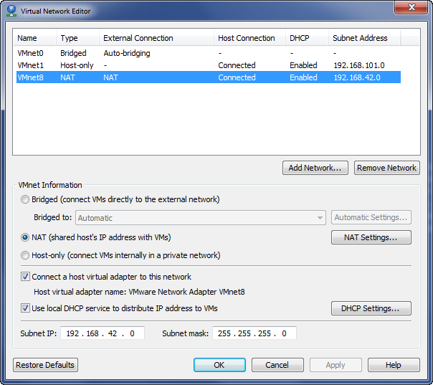



You don’t need to set/change the “DHCP Settings…” as the VMs use fixed IPs.

If the settings are correct, your VM networking is setup correctly and you can proceed to the “Start the IGI Data Server” section.

* If you need to modify the default NAT, change it to match the settings shown above and click Apply

If for some reason you don’t want to change the default NAT to the needed subnet, you can setup a new VMWare network and then change the network interfaces for each VM to use the new network. This is described in A.1 – Configure New Network in VMWare and Change VMs to Use It on page 19.

#### Check and Set VMWare Fusion (Mac) Networking

Unfortunately Fusion does not have a Virtual Network Editor that shows the network configuration for the default NAT network (it does for any custom networks configured).

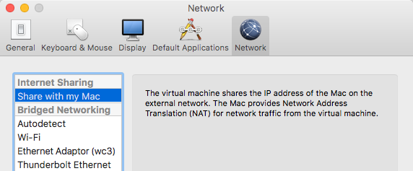

You need to use a command line (shell) to check:

* Open a Terminal session on your Mac
* Edit the file /Library/Preferences/VMware\ Fusion/networking. You can use your editor of choice (like vi or nano) and you may need to use sudo . For example:

davidedw:~ davidedw$ sudo vi /Library/Preferences/VMware\ Fusion/networking

* Locate the entries for vmnet8

They will be at the bottom of the file:

answer VNET_8_DHCP yes

answer VNET_8_DHCP_CFG_HASH CF53FA19F2149A40EB27C901AC3DC2C094A61FB7

answer VNET_8_HOSTONLY_NETMASK 255.255.255.0

answer VNET_8_HOSTONLY_SUBNET 192.168.42.0

answer VNET_8_NAT yes

answer VNET_8_VIRTUAL_ADAPTER yes

If the settings are as above (important are the NETMASK and SUBNET settings) then the default NAT (vmnet8) network is configured correctly and you can proceed to the “Start the IGI Data Server” section.

If you need to change the default NAT:

* Edit the file and make the changes, then save/exit
* Restart VMWare Fusion to apply the network changes

Note – this is covered in a VMWare support article “Modifying the DHCP settings of vmnet1 and vmnet8 in Fusion (1026510)” at <https://kb.vmware.com/selfservice/microsites/search.do?language=en_US&cmd=displayKC&externalId=1026510>.

If for some reason you don’t want to change the default NAT to the needed subnet, you can setup a new VMWare network and then change the network interfaces for each VM to use the new network. This is described in A.1 – Configure New Network in VMWare and Change VMs to Use It on page 19.

## Start the IGI Data Server VM

The IGI Data Server VM contains the IGI datastores. It needs to be running before starting the Virtual Appliance.

* Start the **IGI52x DataServer VM** in the Virtual Machine Library

The image will go through a Linux boot up. When it’s finished it will present the IP address and a login prompt.

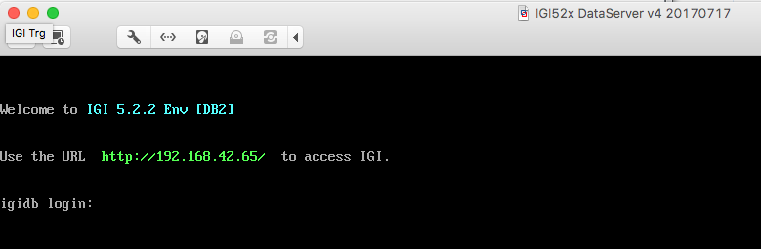

Ignore the message “IGI 5.2.2 Env [DB2]”. It is a hangover from the older VM the training image was copied from.

* Log in with igi/igi
* Run a ps –ef | grep db2 command to check both datastores (IGI DB and IGI LDAP) are running

[igi@igidb ~]$ ps -ef | grep db2

root 1613 1 0 07:49 ? 00:00:01 db2wdog

igiinst 1615 1613 1 07:49 ? 00:00:02 db2sysc

root 1621 1613 0 07:49 ? 00:00:00 db2ckpwd

root 1622 1613 0 07:49 ? 00:00:00 db2ckpwd

root 1623 1613 0 07:49 ? 00:00:00 db2ckpwd

igiinst 1625 1613 0 07:49 ? 00:00:00 db2vend (PD Vendor Process - 1)

igiinst 1633 1613 0 07:49 ? 00:00:00 db2acd ,0,0,0,1,0,0,0,0000,1,0,995bc4,14,1e014,2,0,1,41fc0,0x210000000,0x210000000,1600000,10002,2,a0012

root 1894 1 0 07:49 ? 00:00:01 db2wdog

igildap 1896 1894 5 07:49 ? 00:00:08 db2sysc

root 1902 1894 0 07:49 ? 00:00:00 db2ckpwd

root 1903 1894 0 07:49 ? 00:00:00 db2ckpwd

root 1904 1894 0 07:49 ? 00:00:00 db2ckpwd

igildap 1906 1894 0 07:49 ? 00:00:00 db2vend (PD Vendor Process - 1)

igildap 1914 1894 0 07:49 ? 00:00:00 db2acd ,0,0,0,1,0,0,0,0000,1,0,995bc4,14,1e014,2,0,1,41fc0,0x210000000,0x210000000,1600000,28005,2,138023

igi 2566 2464 0 07:52 pts/0 00:00:00 grep db2

If you see a display similar to above with db2sysc processes for both igiinst and igildap, then both datastores are running.

## Start the IGI Virtual Appliance VM

The IGI Virtual Appliance is started once the IGI Data Store VM is running.

* Start the **IGI 52x Appliance VM** in the Virtual Machine Library

The image will go through the appliance boot up. When it’s finished it will present a login prompt.

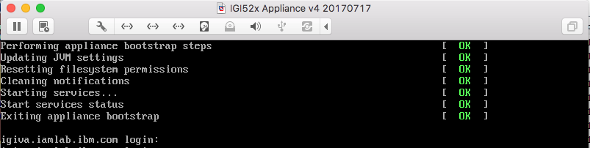

* Log in with admin/Passw0rd! (don’t forget the exclamation mark)

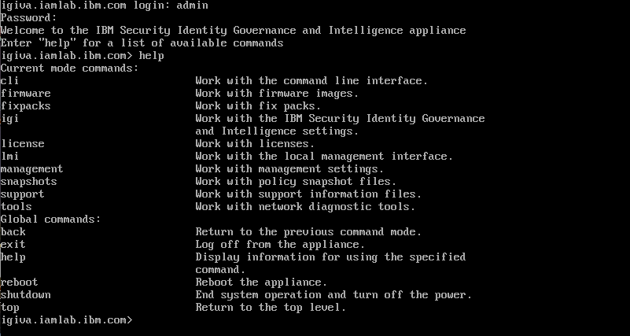

The Virtual Appliance is running. You can enter help to see the list of command options.



This completes the startup of the IGI Virtual Appliance, however we need to check/set the time as there is a problem with time drift between the data server and VA

## Check/Set the Time in the Virtual Appliance

The IGI VA does not have VMWare tools installed (and cannot). This means that the time inside the VA is not tied to the host, and if the VA is stopped/started, the time may be incorrect. The data server VM does have VMWare tools, so it will always be in synch with the host system. This can lead to a “time drift” problem with the VMs where the VA can lag behind, and the lag may be significant. This can cause many problems in the IGI application, such as events sitting unprocessed (waiting for the CA clock to catch up).

To check and set the time in the VA, follow the steps in Appendix B.1 – “Time Drift” Problem on page 32.

## (optionally) Start the Windows Server VM

There are two Windows Server VMs (one at 2008, one at 2016) that contain a Firefox browser and the lab files for various labs. Which one you use will depend on the lab you are running. Depending on the lab, if running your IGI VMs locally, you may not need to use the Windows Server VM (some labs, like AD integration labs need it) – you can use your local web browser and download the lab files to your machine.

If you do want to use it:

* Start the **Windows Server VM** in the Virtual Machine Library
* When Windows starts, press CTRL + ALT + DELETE to login
* For DEMO\Administrator enter a password of “Passw0rd”
* On the first Windows Activation dialog, select Ask Me Later
* On the second Windows Activation dialog, click the OK button

When the Windows desktop appears, you are ready to test.

* Open a Command Window (Start > Command Prompt)
* Run the command ping 192.168.42.65 to test the connection to the IGI Data Server
* Run the command ping 192.168.42.61 to test the connection to the IGI Virtual Appliance interface
* Run the command ping 102.168.42.60 to test the connection to the IGI application interface

If you get a message saying, “Destination host unreachable” that means there is a networking issue. Review your networking configuration.

* Run the command ping igidb.iamlab.ibm.com to test the name resolution for the data server
* Run the command ping igiva.iamlab.ibm.com to test the name resolution for the Virtual Appliance
* Run the command ping igi.iamlab.ibm.com to test the name resolution to IGI

This should work as it’s built into the Windows Server configuration and has nothing to do with your VMWare setup. If there are issues, you can try to fix them in DNS, or just use the IP addresses in the labs.

Note the Windows Server 2016 image is basically the same. You can login with the Administrator or NetworkAdmin accounts. The steps above are the same.

## Check connectivity

Prior to running the application checks, we should confirm that the Virtual Appliance and Data Server can communicate. This will be obvious when trying to use the application, but we will perform network checks anyway.

First, we will check the connectivity from the data server to the virtual appliance

* In the Data Server VM terminal window, ping 192.168.42.60 to confirm connectivity to the VA (CTRL+C to stop it)

[igi@igidb ~]$ ping 192.168.42.60

PING 192.168.42.60 (192.168.42.60) 56(84) bytes of data.

64 bytes from 192.168.42.60: icmp_seq=1 ttl=64 time=0.028 ms

64 bytes from 192.168.42.60: icmp_seq=2 ttl=64 time=0.028 ms

64 bytes from 192.168.42.60: icmp_seq=3 ttl=64 time=0.025 ms

64 bytes from 192.168.42.60: icmp_seq=4 ttl=64 time=0.025 ms

^C

--- 192.168.42.60 ping statistics ---

4 packets transmitted, 4 received, 0% packet loss, time 3316ms

rtt min/avg/max/mdev = 0.025/0.026/0.028/0.005 ms

[igi@igidb ~]$

* In the Virtual Appliance terminal (command line interface) enter tools to go into the tools menu
* Type ping 192.168.42.65 to confirm connectivity to the Data Server (CTRL+C to stop it)

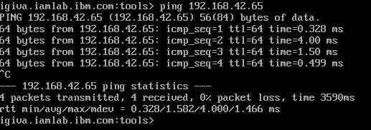

If both pings (Data Server -> VA and VA -> Data Server) work, then the network is setup correctly and ready for the application testing. Proceed to Chapter 5 - Check Environment (Application is Working) on page 16.

If there were any networking issues, check your network configuration. Also have a look at A.2 – Network Issues Seen with Local VMs on page 18.

# Skytap Environment Setup

An environment with all components is built in Skytap and ready to use. This section covers creating an environment from the template and starting the environment.

There are multiple Skytap templates for the training image:

* ***IAM: IGI 52x Training Env | 040 | INSTANCE*** – this is the main training environment. All of the IGI-only labs (i.e. currently Lab01 – Lab07) use this image. If in doubt, select this one.
* ***IAM: IGI 52x Training Env - Integration lab done | 040 | INSTANCE*** – this is a copy of the main training environment that has had the first two lab parts for the Basic/Standard course done. You should only use this image if you’re running the Basic/Essentials course labs (Lab04) and you have progressed past Lab04 part 2.

Note that the IGI Training environment in Skytap does not have external access enabled – you need to use the Windows Server VM to access the IGI VMs.

## Create an Environment from the Template

The IGI training environment template is called “*IAM: IGI 52x Training Env | 040 | INSTANCE*”.

* Log into Skytap
* Go to **Environments > Templates** and find “*IAM: IGI 52x Training Env | 040 | INSTANCE*” or use the “TREFde0001” tag ([https://cloud.skytap.com/templates?query=name%3ATREFde0001*](https://cloud.skytap.com/templates?query=name%3ATREFde0001*) )
* Select the Environment and click the **New Environment** button on the right

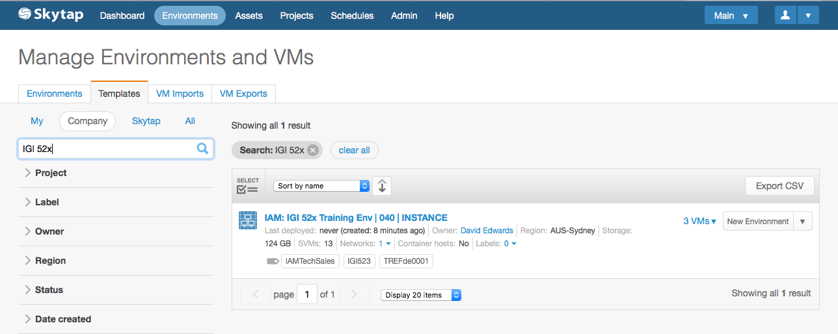

* Give your environment a name and click **Deploy**

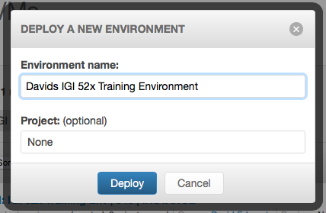

Your training environment is ready to use.

## Starting the Training Environment

The VMs in the environment are already configured with the correct networking and memory/CPU allocation, so you can just start it.

* Open your new environment (it may already be open from when you created it, otherwise select it from your environment list)

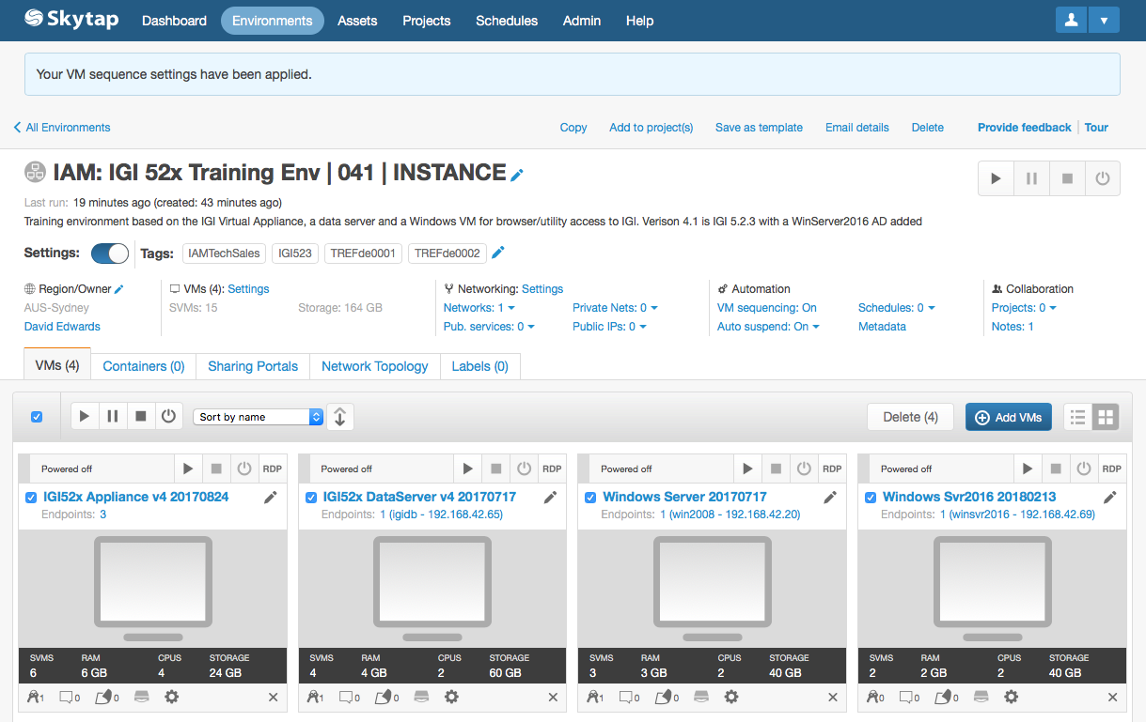

You can see the four VMs in the environment; the IGI appliance, the IGI data server and the two Windows servers. The IGI data server needs to be running before the appliance is started. The environment start will start the IGI data server and Windows server, wait a minute, then start the IGI appliance.

If you need the later Windows Server (Windows Svr2016) for a specific lab you can start it separately (and shut down the other Windows Server) – you only need one or the other.

If you want to start the VMs individually, make sure the IGI data server is up and running before starting the appliance.

* To start the environment, click the right arrow in the top right of the window (immediately below the “Provide feedback” link)

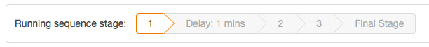

The running sequence stage section will be displayed, and busy icons will appear beside the environment title and the titles for each VM. The VM windows will change from a grey background, to a blue background (as they are being started), to a green background (started).

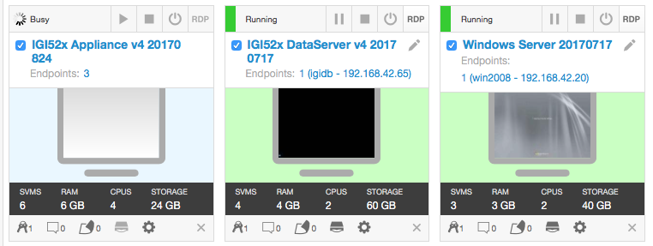

When all three VMs have a green background, they are started. Next, we need to check that they started.

## Check VMs

We will check each VM in turn

* Click on the **IGI 52x DataServer…** VM to open a browser window/tab into that environment
* At the login prompt login with igi/igi
* Change directory to tools (cd tools)
* Check that the two database instances are running (ps –ef | grep db2)

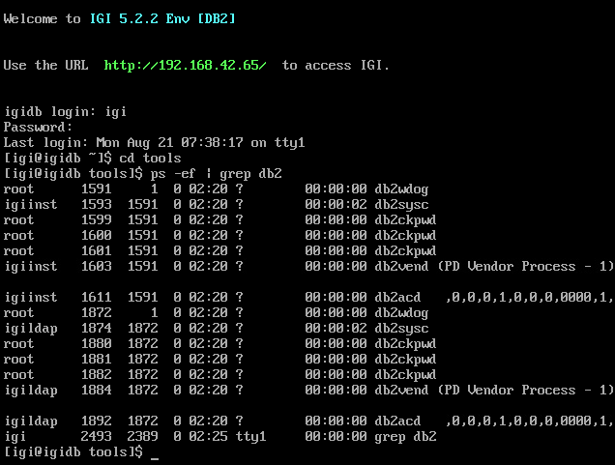

Ignore the opening message saying IGI 5.2.2 – the environment is at 5.2.3.

If you see both DB2 instances running (db2sysc process for igiinst and igildap), the VM has started correctly.

* Close the browser window/tab for the IGI data server
* Back on the Skytap environment view, click on the **IGI 52x Appliance…** VM to open a browser window/tab into that environment
* Login with admin/Passw0rd! (note exclamation mark)

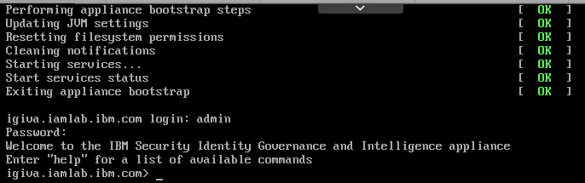

If this works, the appliance is ok.

* Close the browser window/tab for the IGI appliance
* Back on the Skytap environment view, click on the **Windows Server…** VM to open a browser window/tab into that environment
* Use the Ctrl-Alt-Del botton in the Skytap toolbar to send a Ctrl+Alt+Del to the Windows server
* Login with Demo\administrator/Passw0rd

The Windows Server is not activated and we will skip activation.

* Click **Ask me later** on the Windows Activation dialog
* Click **OK** on the second Windows Activation dialog

The environment is now ready for testing prior to running labs. You can now proceed to Check Environment (Application is Working) on page 20.

# SCS-Portal Environment Setup

The Security CloudSpace Portal (aka. SCS-Portal, IBM Remote Lab Reservation, IRLP), <https://ibm.biz/scsportal> , is an IBM portal front-ending Skytap. It allows instances of Skytap templates (called “profiles”) to be scheduled for training and demo purposes.

There are SCS-Portal profiles corresponding to the Skytap templates listed in the previous section:

* ***Security Solutions / DM0000184 – IAM: IGI 5.2.x Training Environment*** – this corresponds to the *IAM: IGI 52x Training Env | 040 | INSTANCE* and is the profile that should be used for all labs
* ***Security Solutions / DM0000225 – IAM: IGI 5.2.x Training Environment - Integration Lab Done*** – this corresponds to the *• IAM: IGI 52x Training Env - Integration lab done | 040 | INSTANCE* and is the profile that should only be used by people doing the Basic/Essentials labs (Lab04) and have progressed past Part 02 of the lab.

## Scheduling a Profile Instance

If you are in a training class, your instructor may have scheduled instances for you. If you have been given a URL (like https://labs.edu.ihost.com/nd.5002389.s1/ec4b) then you can skip the following and go straight to starting your environment.

To schedule a demo:

* Go to SCS-Portal (<https://ibm.biz/scsportal> ). The default page is the Schedule a Demo page
* Select Security Solutions for the **Curriculum unit** and select the **IGI Demonstration Profile** you need

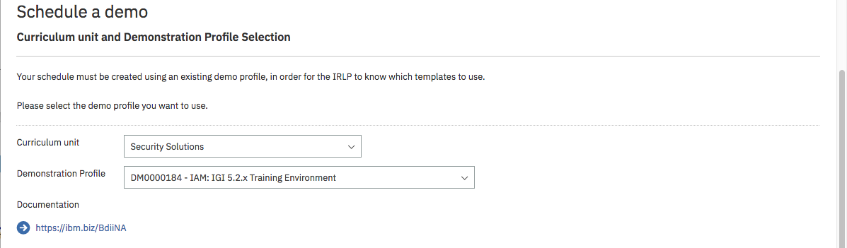

When you select the appropriate profile, the page will refresh and you will see a documentation link as shown.

* Enter **Schedule information** based on your purpose for using the profile:
* **Demonstration Name** – you must give it a name
* **Opportunity number** – if this in support of a sales opportunity you should include an opportunity number. This is checked against a live DB. If there are problems you can include it I the Customer name –or- Description field
* **User e-mail** – this will be your email
* **Contact e-mail** – this is used when instances are scheduled for other people (note – the owner of the profile will also get an email when an instance is scheduled)
* **Number of instances** – admins can select >1, all other users can only request a single instance (if you need multiples, you need to contact one of the admins)
* **Demo purpose** – select from one in the pull-down list
* **Customer name** -or- Description – this will depend on the purpose
* **Time zone** – it should default to your time zone
* **Start data** – either a future start date or you can specify Start now to have it instantly scheduled
* **End date** – the date it will automatically be removed. Note that the max duration for any instance is set when the profile is defined and will normally be 2-3 days. If you are running course (or personal training) longer than that you may need to schedule multiple instances or contact an admin to see if it can be extended

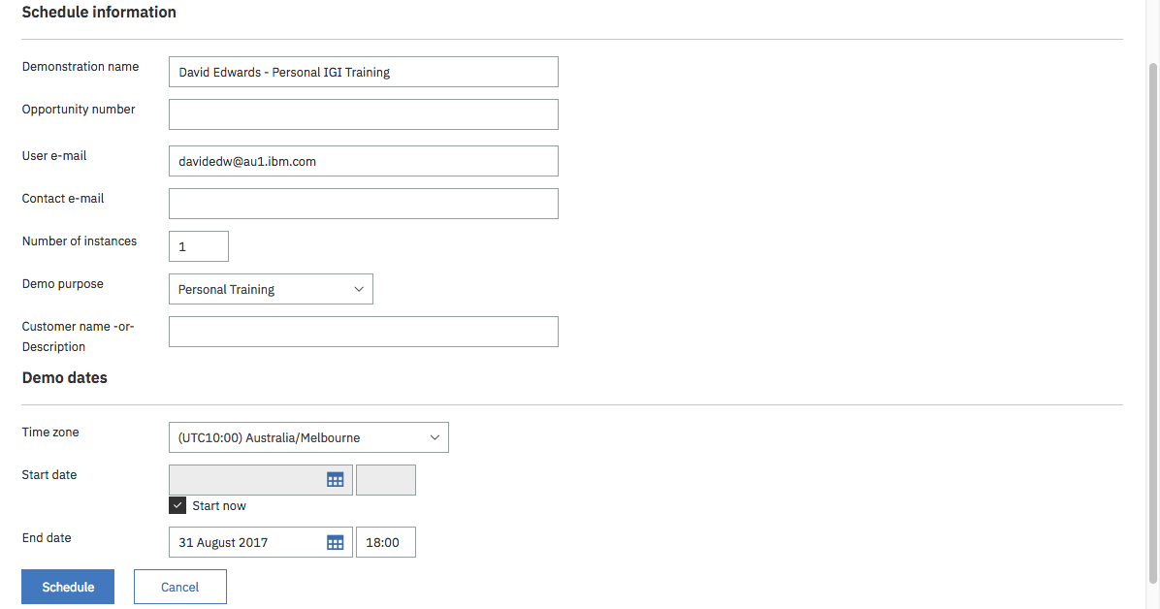

* Click **Schedule**

The page will be refreshed, and you will see a message indicating your instance has been booked.

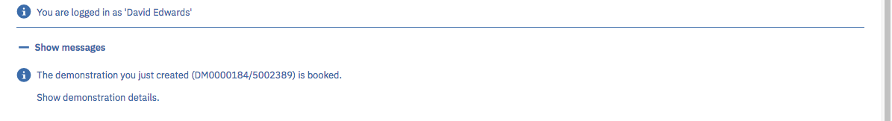

* Click on the **Show demonstration details** link

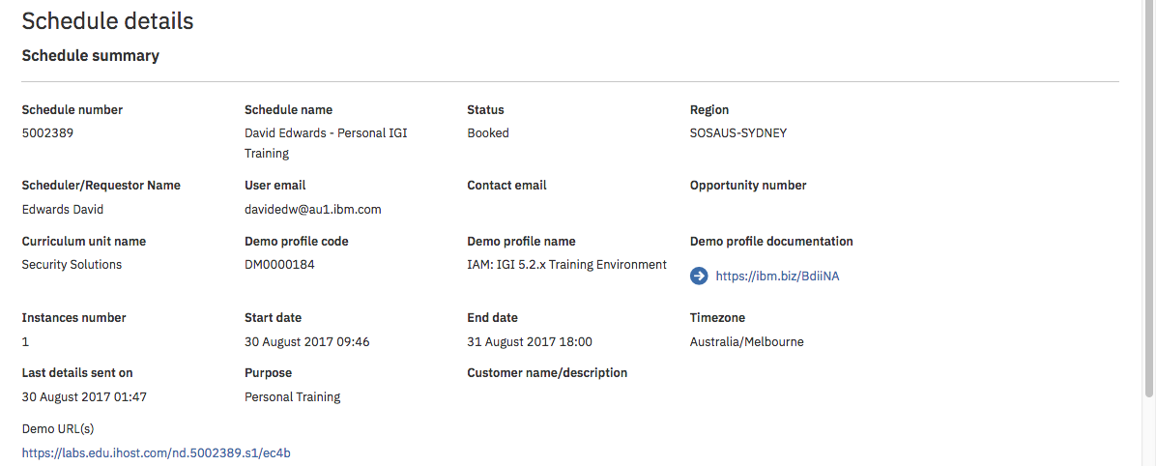

It shows all the details of your scheduled instance. Note the Demo URL(s) at the bottom. This is the link you use to access the instance.

## Accessing the Profile Instance

To access the profile instance:

* Click the Demo URL(s) link from the Schedule details page (or given to you by your instructor).

This will take you into Skytap

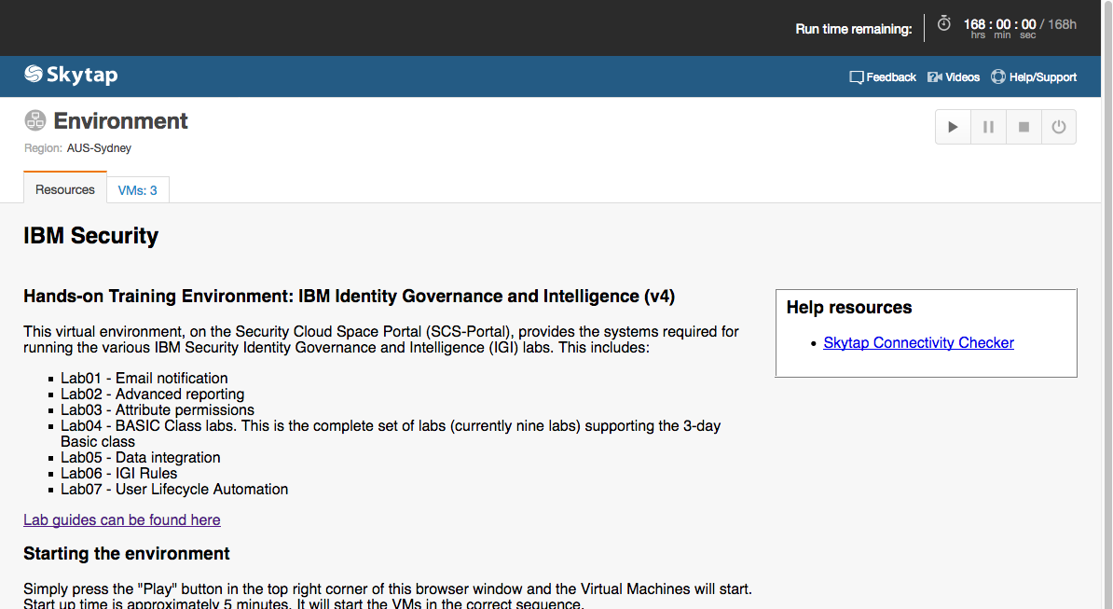

The top of the page shows you how much time you have remaining for this instance.

The main part of the page provides instructions (“Resources”) for this instance. It will look different for different profiles and covers lab guides, startup instructions and other useful information.

There is a second tab that shows the VMs for this instance (note the new Windows Svr2016 is not shown).

* Select the **VMs** tab

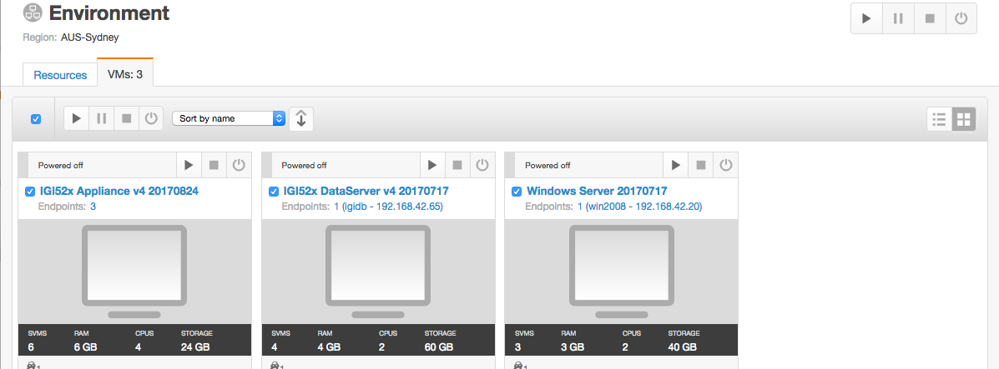

The environment is now ready to start.

## Starting the Training Environment

To start the training environment:

* Click the arrow button on the top right of the page

The background of each VM will change to light blue.

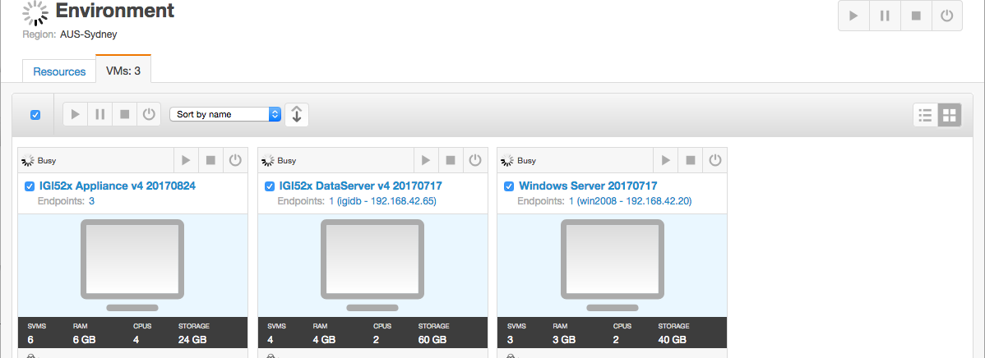

As the VMs start, the background will change to green. In most IGI training environments there is a startup sequence (e.g. data server must be running before the virtual appliance) so you might see some VMs start before others.

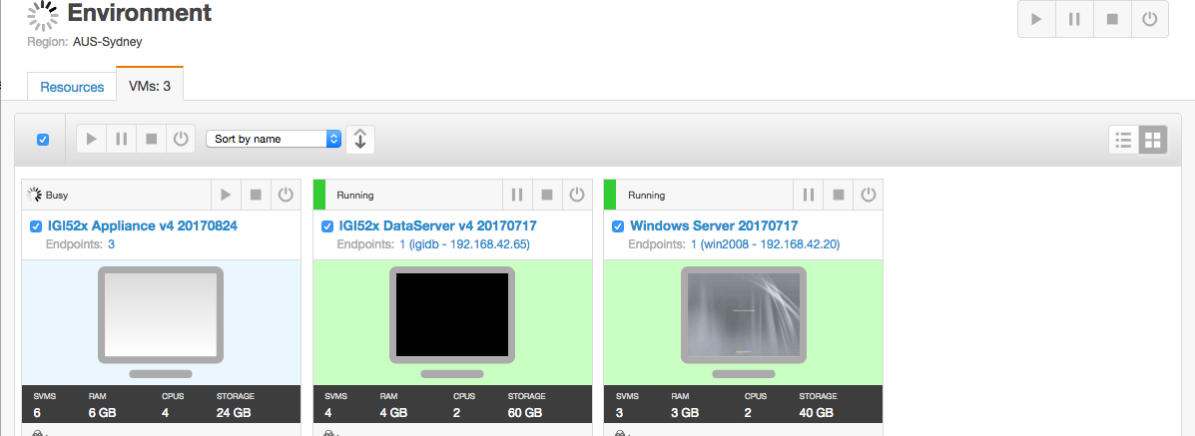

When all VMs are started, the Environment icon will change to green.

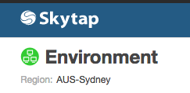

If you need the Windows Server 2016 image for a lab, you will need to start it separately. If you do, you can also stop the Windows Server 2008 image.

We will now test (the following is based on the standard IGI training image)

## Check VMs

We will check each VM in turn

* Click on the **IGI 52x DataServer…** VM to open a browser window/tab into that environment
* At the login prompt login with igi/igi
* Change directory to tools (cd tools)
* Check that the two database instances are running (ps –ef | grep db2)



Ignore the opening message saying IGI 5.2.2 – the environment is at 5.2.3.

If you see both DB2 instances running (db2sysc process for igiinst and igildap), the VM has started correctly.

To close this window and return to the VM view:

* Select the **Environment VMs** icon in the task bar (two monitors overlapped)

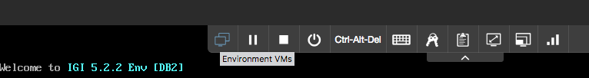

* Click on the **View all VMs** link

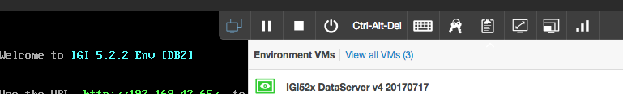

* Back on the Skytap environment view, click on the **IGI 52x Appliance…** VM to open a browser window/tab into that environment
* Login with admin/Passw0rd! (note exclamation mark)



If this works, the appliance is ok.

* As above, go back to the the all VMs view
* Back on the Skytap environment view, click on the **Windows Server…** VM to open a browser window/tab into that environment
* Use the Ctrl-Alt-Del botton in the Skytap toolbar to send a Ctrl+Alt+Del to the Windows server
* Login with Demo\administrator/Passw0rd

Most labs do not need to access the IGI Data Server or IGI Appliance shells – most access is via the Windows Server.

The Windows Server is not activated, and we will skip activation.

* Click **Ask me later** on the Windows Activation dialog
* Click **OK** on the second Windows Activation dialog

The environment is now ready for testing prior to running labs. You can now proceed to Check Environment (Application is Working) on page 20.

# Check Environment (Application is Working)

The following checks will confirm the environment is ready to run labs. These checks should be done irrespective of whether you are using local VMs, Skytap or SCS-Portal.

## Check Virtual Appliance

We will first check that the Virtual Appliance is running.

* Make sure all VMs are running
* Using the Firefox browser in the Windows Server VM, go to <https://igiva.iamlab.ibm.com:9443/>

Notes:

1. If you are running local VMs you have the option of using a local browser. You can use the IP addresses or update your hosts file to use the same hostnames as in DNS.
2. The Firefox browser in the Windows Server has bookmarks for the IGI Virtual Appliance and the two IGI user interfaces

* Log in with admin/Passw0rd! (note the exclamation mark)

You should be presented with the IBM Security Identity Governance and Intelligence Local Management Interface (LMI), similar to the following.

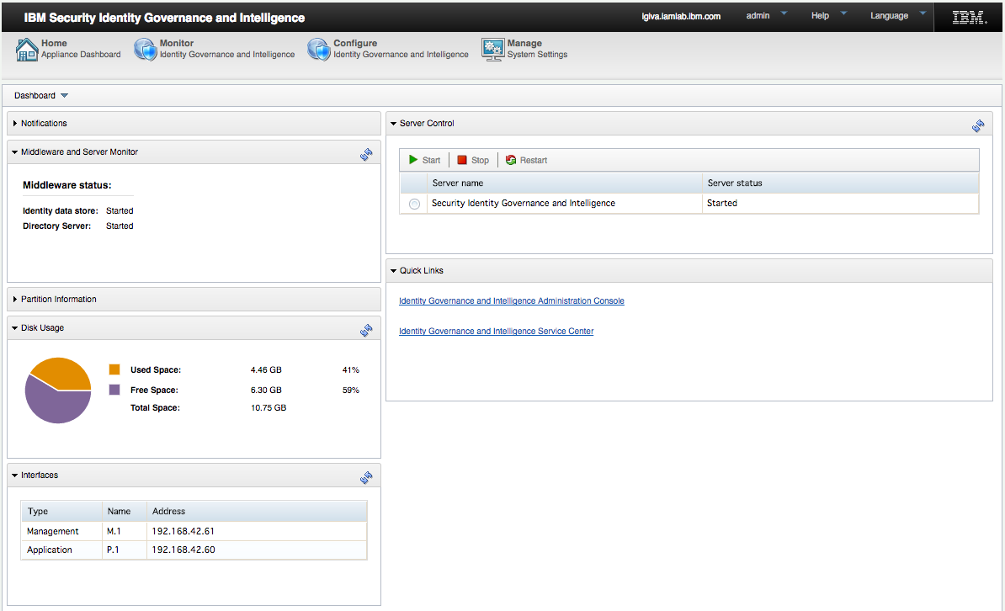

You can see that the **Middleware and Server Monitor** widget is showing both the database and directory are running. The **Server Control** widget shows that IGI is started. The Virtual Appliance is running.

This is a good point to check that the time set on the Virtual Appliance is the same as the time set on the IGI Data Server. See the instructions in B.1 – “Time Drift” Problem on page 28. If you changed the time you may want to restart the IGI Virtual Appliance by using the reboot option in the command line interface.



## Check IGI

Next, we will check the IGI application.

* Open a new browser tab or window and go to <https://igi.iamlab.ibm.com:9343>

Note – you could have also used the links in the Quick Links widget to go directly to the different IGI UIs.

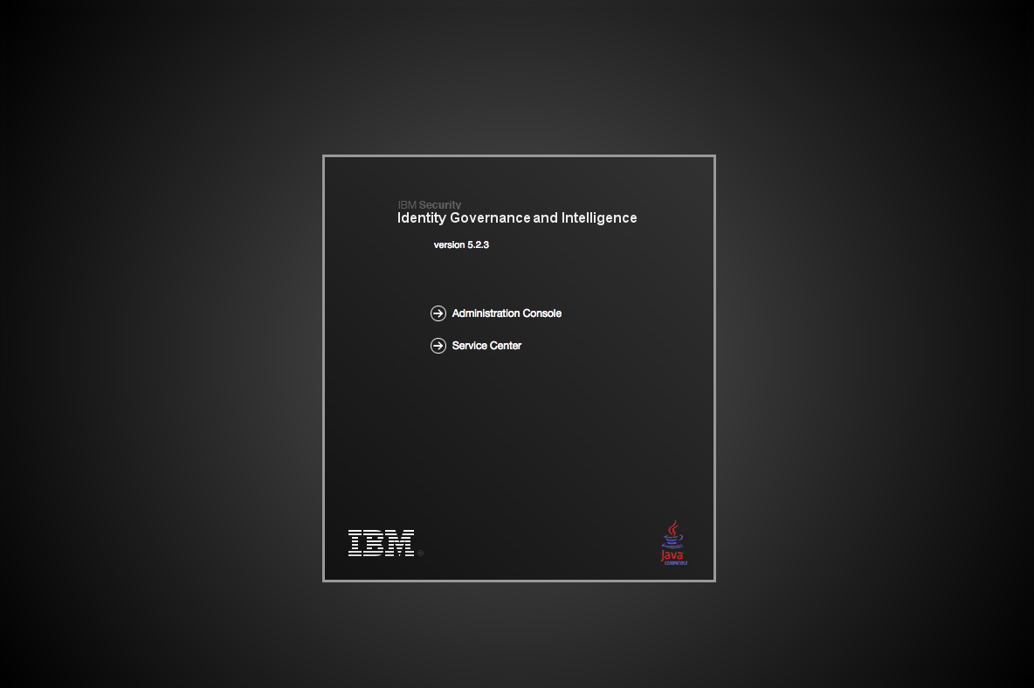

* On the Identity Governance and Intelligence Splash page, click the Administration Console link
* Log in with admin/admin

You should see the IGI Admin Console Home page.

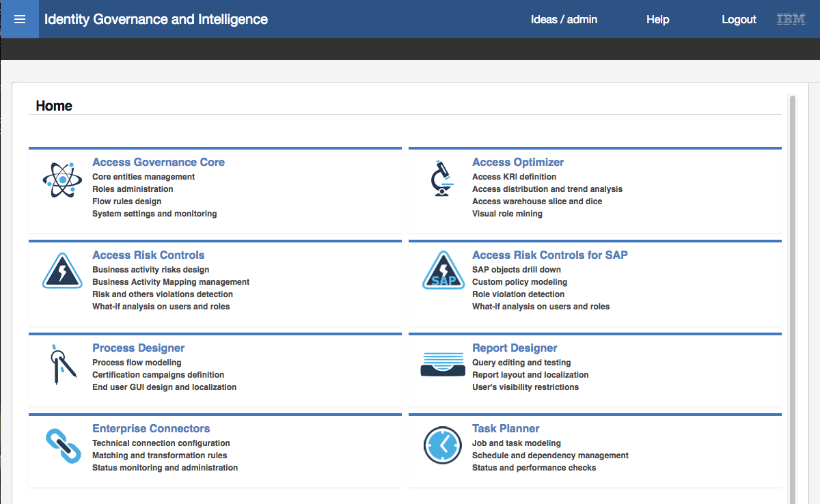

* Click on the **Access Governance Core** module

You should see users displayed under the **Manage > Users** tab.

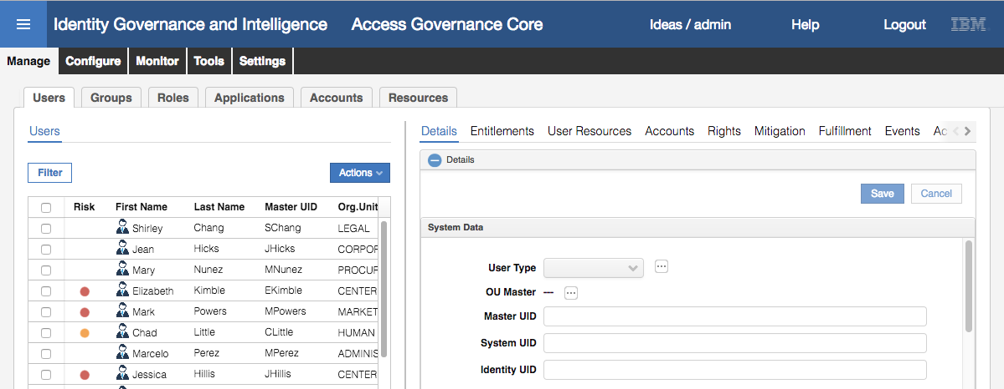

This confirms that the IGI application is running and can communicate with the IGI database.

## Check Enterprise Connectors and Identity Brokerage

The last set of checks relate to the Identity Brokerage module used for connecting to target systems. To confirm its working:

* Go to the **IGI Admin Console Home page** (use the menu icon at the top-left of any screen)
* Click on the **Enterprise Connectors** module

The default view is the **Monitor > Connector Status** tab.

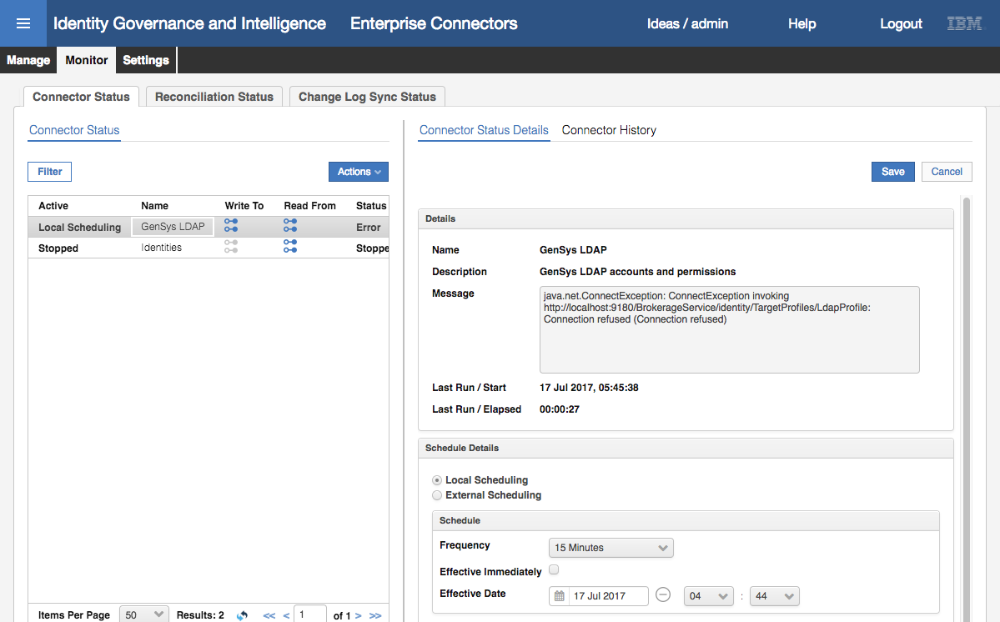

You will probably see that the GenSys LDAP connector is showing as in error. We will fix this.

* With the GenSys LDAP connector selected, select **Actions > Stop**
* Click **OK** on the Stop dialog

The connector will now be shown in a Stopped state.

* With the GenSys LDAP connector selected, select **Actions > Start**

The connector will go into a Pending state.

* Click on the **Connector History** in the right panel to see the history of when the connector has run

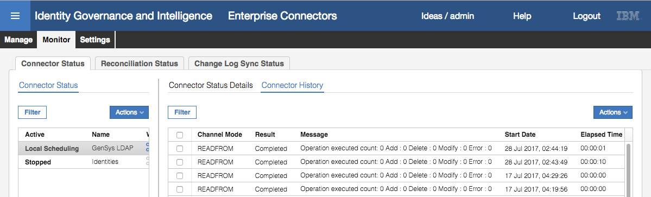

You should see a READFROM event that ran recently. This indicates that the Connector was able to communicate with the Identity Broker.

We will now test the end to end components for this LDAP connector (i.e. IGI – Identity Broker – TDI – LDAP)

* Still within the Enterprise Connectors module, go to **Monitor > Change Log Sync Status**
* Select the GenSys LDAP connector (it is in a Stopped state with an error)

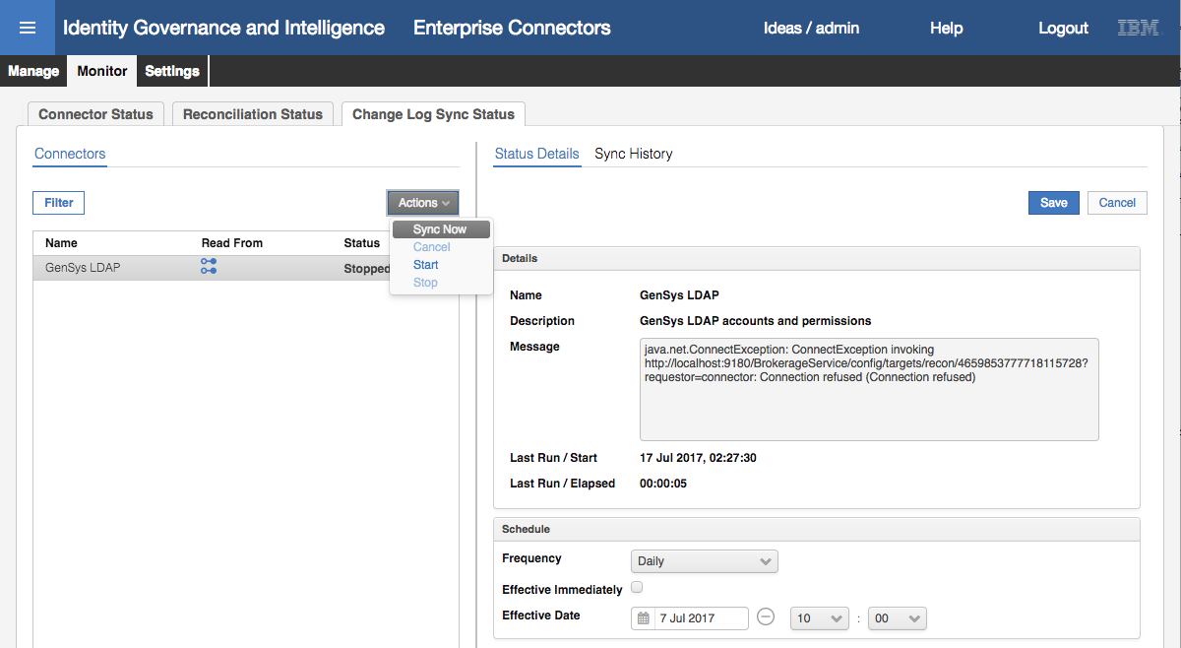

* Select **Actions > Sync Now**

This will initiate a recon from the LDAP target, via TDI to the Identity Brokerage component.

* Select **Sync History** in the right pane to see the results

You should see a recent sync with a success status (green tick icon).

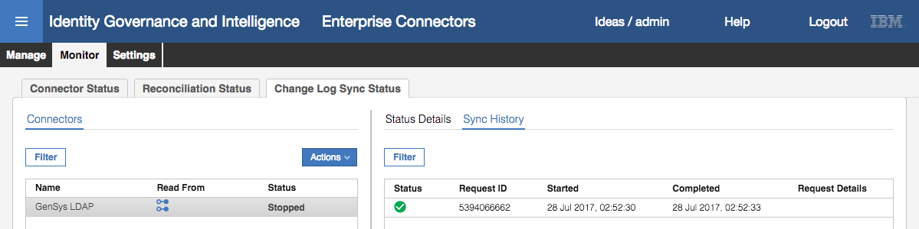

This confirms that all components are running. You are ready to start your lab(s).

# Appendices

The appendices are:

A – Local VM Networking Configuration and Issues

B – Common Issues with the Training Environment

C – Setup Mail Client for Labs

D – Environment Utilities

E – IGI Data Server VM Components

# Appendix A – Local VM Networking Configuration and Issues

This appendix contains a number of topics relating to the use of Local VMs, particularly around network configuration and issues.

If you are using one of the cloud training environments, you don’t need to worry about this.

## A.1 – Configure New Network in VMWare and Change VMs to Use It

It is assumed that you will use the default NAT network (vmnet8) for the lab images. However, if you don’t want to change the default NAT network, you can create a new network and change the VMs network cards to use it. If you are going to use the default NAT network as described in the main body of this document, do not do these steps.

The process to do this in VMWare Workstation and VMWare Fusion is the same, but the UI is slightly different. The following sections describe the steps for each.

If you are using VMWare Player on a Windows machine, see the separate steps in A.4 – Using VMWare Player with the Training Image on page 39.

### A.1.1 – Add a New Network to Workstation and Set VM Network Adapters

To add a new network in VMWare Workstation:

* Start virtual network editor (Edit > Virtual Network Editor)
* Click the Add Network… button
* Select an available network

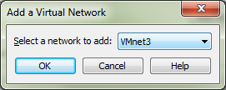

* Click OK
* Select it and enter the following values:
* VMnet Information – Host-only (you can only have one NAT network)
* Select Connect a host virtual adapter to this network
* Select Use local DHCP service to distribute IP address to VMs (not really needed as all the VMs use a fixed IP)
* Set the Subnet IP to 192.168.42.0
* Set the Subnet mask to 255.255.255.0

It should look like the following:

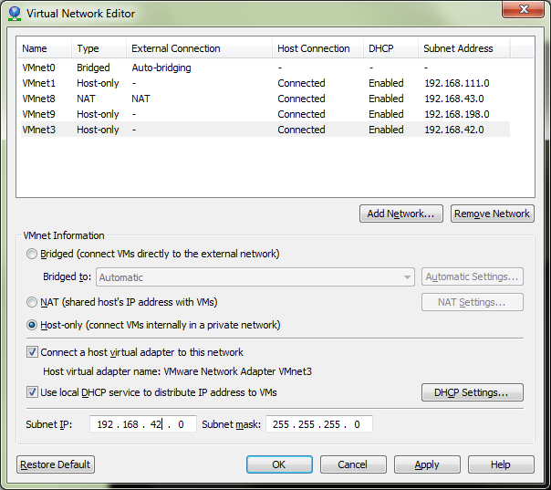

* Click OK

VMWare will go through some steps to reload the network configuration.

Next, we need to go through all VMs in the training environment (IGI Data Server, IGI Virtual Appliance and optionally the Windows Server) and set the network adapters to use the new network.

For each VM:

* Open the VM (don’t start it) and click the Edit Virtual Machine Settings link (or menu VM > Settings)
* Select the Network Adapter
* In the Network connection panel, select the Custom: Specific virtual network
* In the pull-down list, select the new network you created earlier

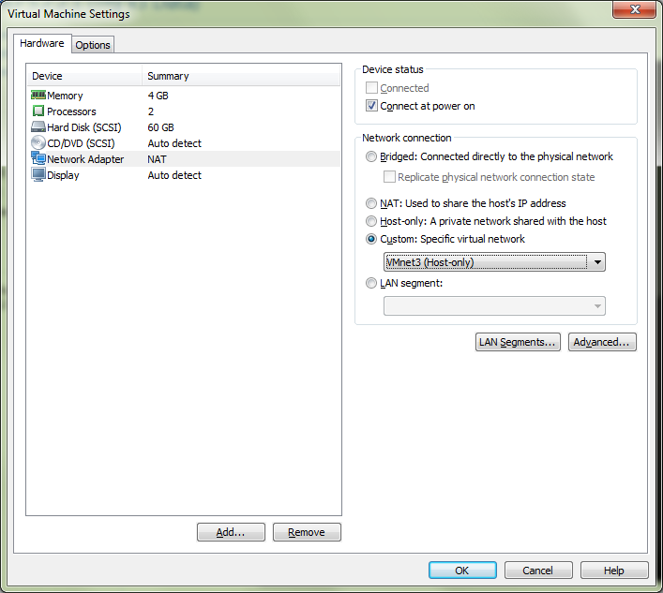

* Repeat for any other network adapters (the Virtual Appliance has three)

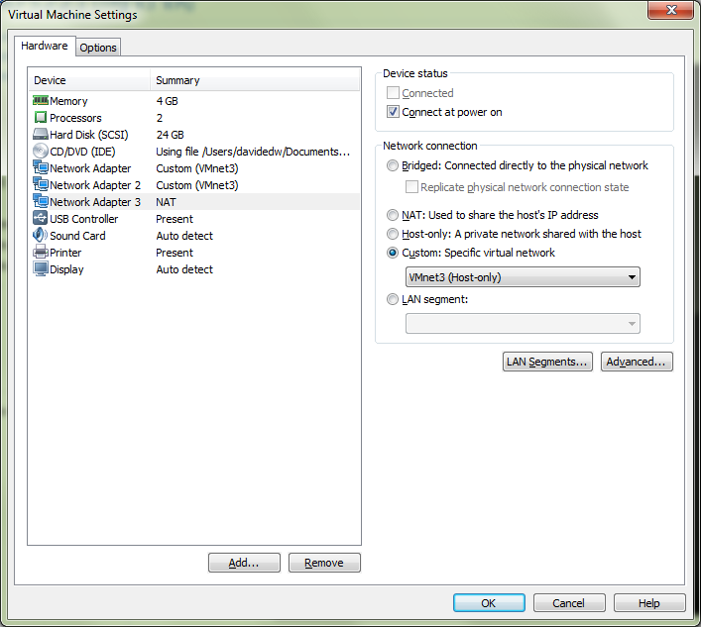

* When you’ve set all network adapter for the VM, click OK

You should see the **Custom (VMnet*)** beside each network interface.

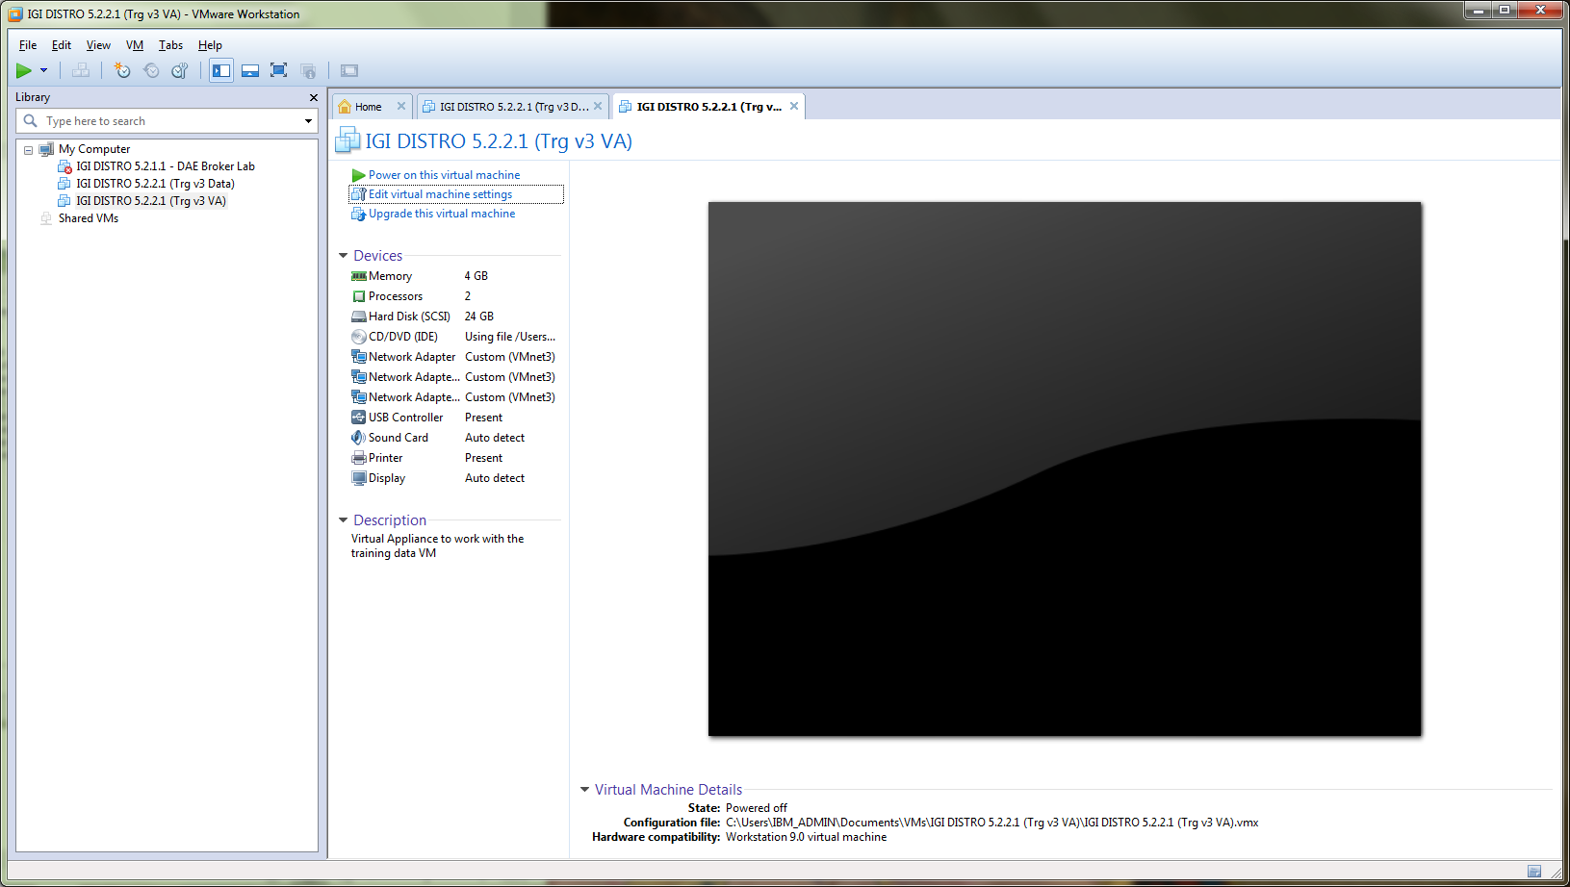

* Repeat for all IGI training VMs.

You can now continue with the steps in the main body of the document.

### A.1.2 – Add a New Network to Fusion and Set VM Network Adapters

To add a new network in VMWare Fusion:

* Go to VMWare -> Preferences
* Click the Network icon to go to the Network tab
* Click the Lock to Make changes and enter your Mac password when prompted
* Click the Plus sign (+) below the list to add a new network

Fusion will create a new vmnet* (next available number). The example below shows vmnet5, but depending on what you have configured already it may be a different number.

* Set the following values for the existing 192.168.42.0 network:
* “Allow virtual machines on this network to connect to external networks (using NAT)”
* “Connect the host Mac to this network”
* “Provide addresses on this network via DHCP”
* Subnet IP – 192.168.42.0
* Subnet Mask – 255.255.255.0

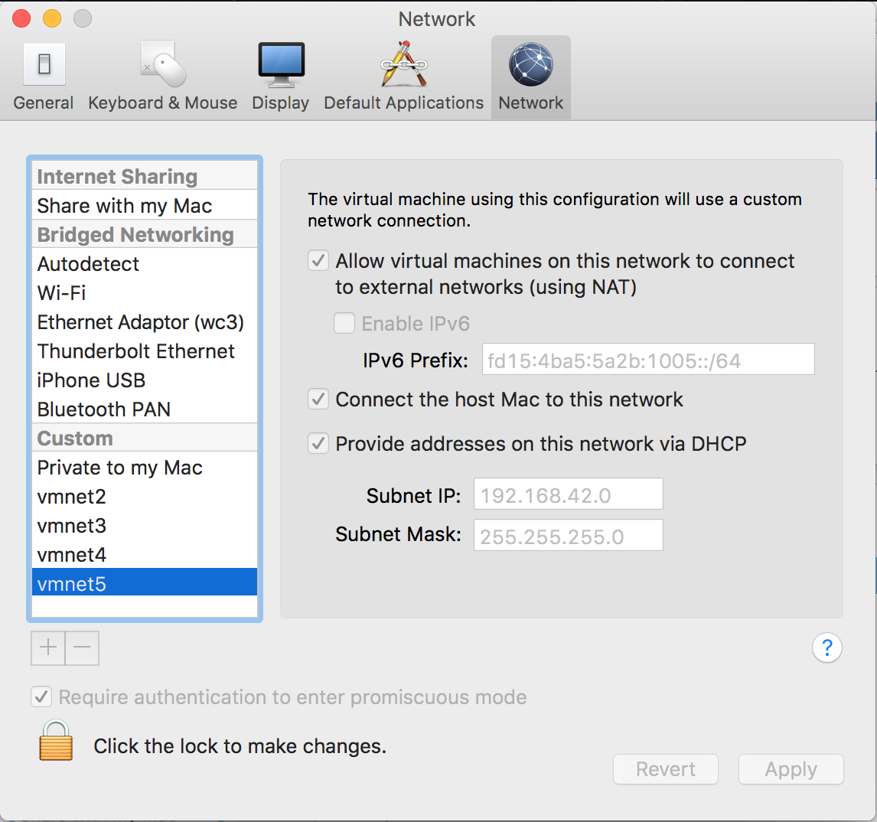

* Click Apply and “Click the lock to make changes”.

Next, we need to go through all VMs in the training environment (IGI Data Server, IGI Virtual Appliance and optionally the Windows Server) and set the network adapters to use the new network.

For each VM:

* In VMWare Fusion, open (but do not start) the virtual machine.
* Click Settings (wrench icon) or Virtual Machine > Settings in the menu.
* Under the Removable Devices title, click on the network adapter(s) you need to modify.

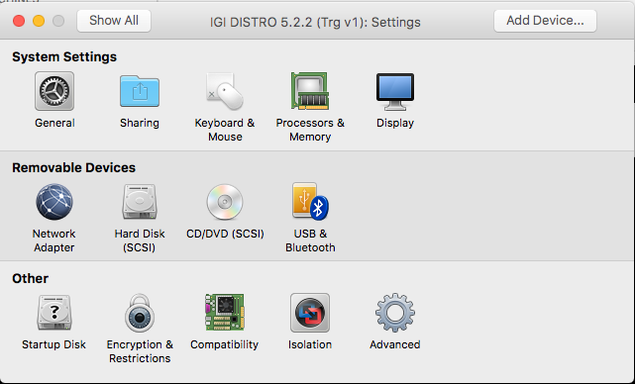

* Ensure the network adapter is the one you set/created in the previous section

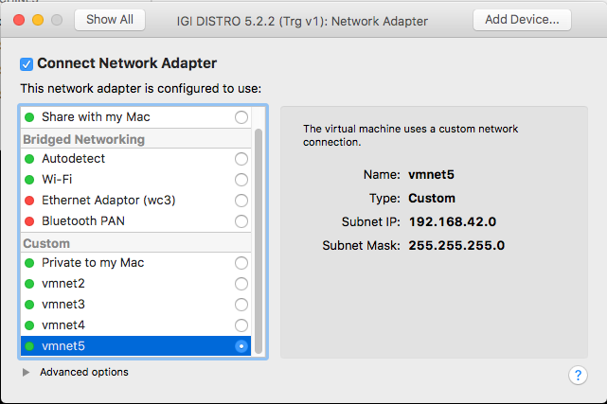

* Close the Settings dialog

All VMs should be able to communicate, as per the checks in the lab guide. If you have problems, check the next section.

## A.2 – Network Issues Seen with Local VMs

There are two main causes of network issues with this training environment; network not configured correctly, and the IGI Data VM losing the ent0 definition. If you have problems communicating between VMs, you should first check the network configuration. If it is ok, check for eth0 on the Data Server

### A.2.1 – IGI Data Server Loses eth0

There is a common problem with CentOS where network changes may cause corruption or removal of the eth0 (default Ethernet) definition. This is often seen when the VM is started but the network configuration is not correct.

To check for the problem:

* Log into the command line (shell) for the IGI Data VM
* At the prompt enter ifconfig

[igi@igi tools]$ ifconfig

eth0 Link encap:Ethernet HWaddr 00:0C:29:F3:86:94

inet addr:192.168.42.60 Bcast:192.168.42.255 Mask:255.255.255.0

inet6 addr: fe80::20c:29ff:fef3:8694/64 Scope:Link

UP BROADCAST RUNNING MULTICAST MTU:1500 Metric:1

RX packets:28018 errors:24448 dropped:0 overruns:0 frame:0

TX packets:26630 errors:0 dropped:0 overruns:0 carrier:0

collisions:0 txqueuelen:1000

RX bytes:4695230 (4.4 MiB) TX bytes:22882814 (21.8 MiB)

Interrupt:18 Base address:0x2024

lo Link encap:Local Loopback

inet addr:127.0.0.1 Mask:255.0.0.0

inet6 addr: ::1/128 Scope:Host

UP LOOPBACK RUNNING MTU:65536 Metric:1

RX packets:62335703 errors:0 dropped:0 overruns:0 frame:0

TX packets:62335703 errors:0 dropped:0 overruns:0 carrier:0

collisions:0 txqueuelen:0

RX bytes:60474509950 (56.3 GiB) TX bytes:60474509950 (56.3 GiB)

If there is no eth0, then you have the issue. If you have an eth0 but you can’t connect to the VM, it may be corrupted.

* In both cases enter the following commands to delete the current definitions (the reboot will rebuild the definitions)

[igi@igi tools]$ cd /etc/udev/rules.d/

[igi@igi rules.d]$ sudo rm 70-persistent-net.rules

[sudo] password for igi:

[igi@igi rules.d]$ sudo reboot

This should resolve issues.

## A.3 – Other Issues Seen with Running VMWare

This section lists other common issues found when trying to run the VMs in VMWare.

### A.3.1 – Intel VT-x Disabled Error

Attempting to start a VM you get an error dialog like the following.

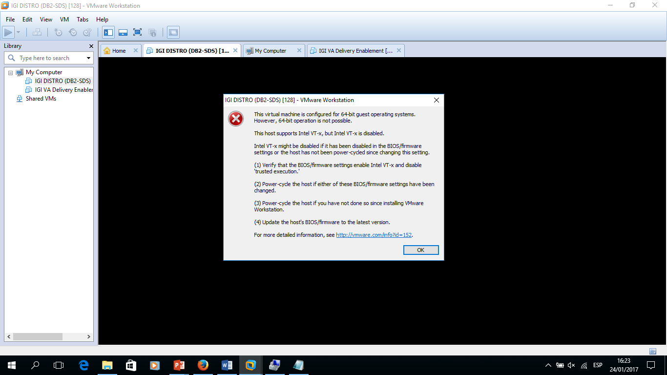

This is an issue with the local machine and BIOS settings.

To resolve the issue, the local machine will need to be rebooted to access the BIOS, then enable both settings (VT-x and VT-d related) under Security -> Virtualization.

For more information see: <https://communities.vmware.com/thread/464586?start=0&tstart=0>

## A.4 – Using VMWare Player with the Training Image

You can use VMWare Player to run the training image. It has been used successfully in some classes but requires configuration of both VMWare and the images (similar to above). The following sections describe the steps to do this.

### A.4.1 – Update the Local Hosts File

You should define hosts entries for the two VMs:

* Use Notepad or Notepad++ to edit C:\Windows\System32\drivers\etc\hosts and add

192.168.42.61 igiva.iamlab.ibm.com

192.168.42.60 igi.iamlab.ibm.com

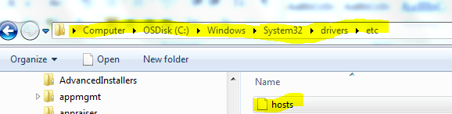

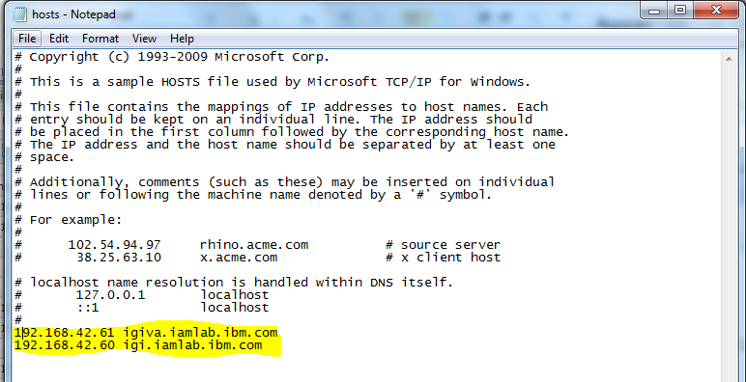

Save the file

### A.4.2 – Update Windows Network Setting for vmnet8

The network configuration of the network the VMs will use needs to be changed. To do this:

* Right click on the **Networking** icon in the lower right of the Windows desktop



* Select **Open Network and Sharing Center**
* On the Network and Sharing Center page, select **Change Adapter Settings**

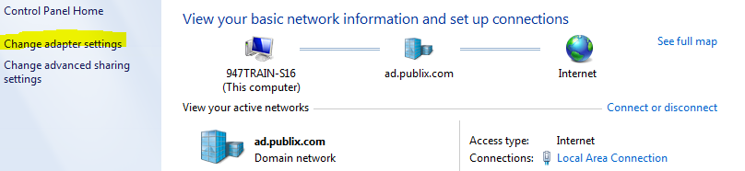

* Double-click the **VMware Network Adapter VMnet8** to open it

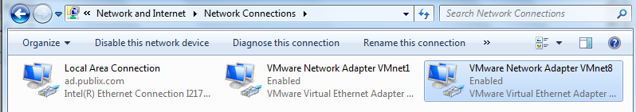

* On the VMware Network Adapter VMnet8 Status dialog, click the **Properties** button
* On the Properties dialog select the **Internet Protocol Version 4 (TCP/IPv4)** and click the **Properties** button

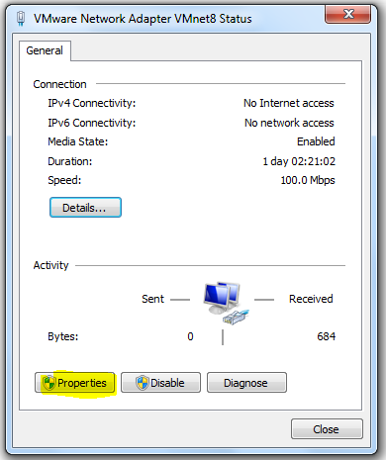🡪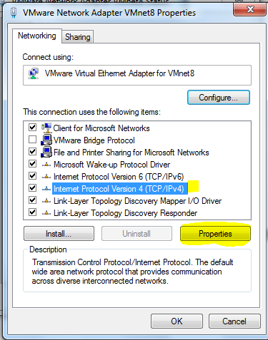

* On the Internet Protocol Version 4 (TCP/IPv4) Properties dialog, change the IP address to be 192.168.4.1 and ensure the subnet is 255.255.255.0.

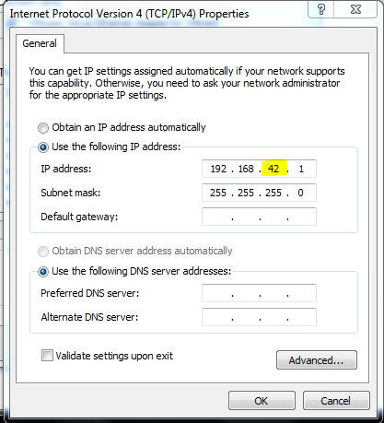

* Click **OK** to save the changes.
* Click **Close** on the Internet Protocol Version 4 (TCP/IPv4) Properties dialog and then on the Internet Protocol Version 4 (TCP/IPv4) Status dialog
* Close the network connections window

### A.4.3 – Update all the VMs to Use the VMnet8

You will need to ensure all VMs are using the VMnet8 network. There is one network card on the data server, three on the virtual appliance and one on each of the Windows servers (if you are using either of them for the labs). To do this:

* Make sure all of the VMs are shutdown
* Open the **VMWare Player** application
* For each VM, right-click and choose **Settings**
* Find and select the **Network Adapter** (for the virtual appliance we will do these steps three times)

The network will be shown as the default NAT. We need to change this to a custom VMnet8.

* Select the radio button beside Custom: Specific virtual network and select VMnet8 (NAT) from the pulldown menu

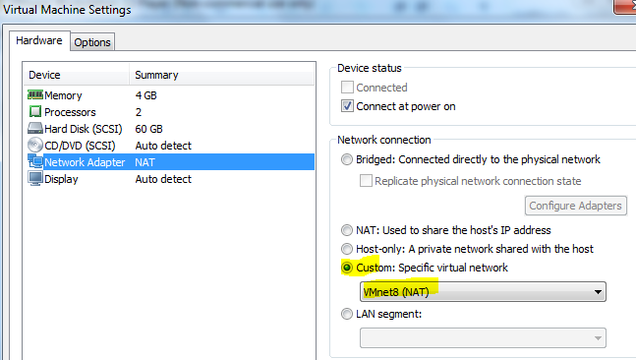

* Repeat for all Network Adapters on the virtual appliance and for all the VMs
* Follow the steps in the next section, which includes the correct VM startup order

### A.4.4 – DB VM Network Fix

Starting the database VM with an incorrectly defined network can cause issues. The following steps will ensure it’s working.

* Start the DB VM and wait until the login prompt appears
* Login in igi/igi
* Run the following commands to flush the networking and pick up the correct network

[igi@igi tools]$ cd /etc/udev/rules.d/

[igi@igi rules.d]$ sudo rm 70-persistent-net.rules

[sudo] password for igi:

[igi@igi rules.d]$ sudo reboot

* Wait for the reboot and login again
* Run ifconfig to confirm that there is an entry for eth0 and it’s mapped to 192.168.42.65

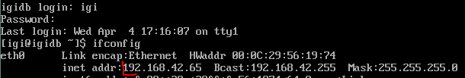

* Start the virtual appliance (If you need to use either Windows server VMs, you can start them also)
* When the virtual appliance is running (i.e. the terminal window shows a login prompt), go to the virtual appliance Local Management Interface at <https://igiva.iamlab.ibm.com:9443/login> (admin/Password!)

If the browser displays an Untrusted Site error, proceed to trust the certificate under the advanced link in the browser.

* Log in to the VA Local Management Interface (admin/Password!)
* Click on the link for the Administration Console

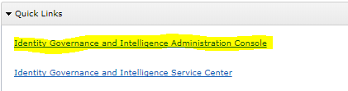

If the browser displays an Untrusted Site error, proceed to trust the certificate under the advanced link in the browser.

* Log into the Admin Console (admin/admin)

If you can successfully log into the admin console, then the environment is running and the VMs are communicating correctly. You are ready to start the lab.

# Appendix B – Common Issues With the Training Environment

This appendix lists some common issues found with the images and how to resolve them.

## B.1 – “Time Drift” Problem

The Virtual Appliance doesn’t have VMWare tools installed or any other external time synchronization mechanisms. There is a way to configure NNTP, but it has proven problematic and is not configured in any of the training VMs.

This can be a problem with time-based transactions. They are stored in the database (on the data server) but accessed via the application (on the virtual appliance). If the images are shut down for some time and restarted, the data server will set it’s time to the current host time but the VA will still be at the earlier time. The application will not process events as the time on the events in the database are later than the time in the application. This is most apparent in IGI where you will see events sitting in an Unprocessed state.

To correct this time drift, you need to find out the time on the data server and set the VA to match.

To find the time on the data servers:

* The PIM data server is the Windows Server, so just check the date/time shown on the desktop.
* The IGI data server is a Linux system, so run the date command (as shown below):

[igi@igidb ~]$ date

Tue Jul 4 01:55:30 CEST 2017

To set the time on the VA you need to access either the VA Local Management Interface (Web UI) or command line.

On the Local Management Interface go to Manage -> System Settings -> Date/Time

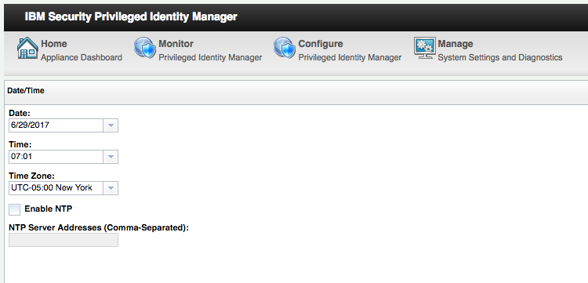

Check the **Time Zone** (and correct if necessary) then set the **Date** and **Time** to match the data server, then click Save Configuration.

If you change the time, you may want to restart the application from the VA LMI Home page.

## B.2 – Suspended VA Lost Connection to Data Servers

If you suspend and later restore the Virtual Appliance you may find that you cannot log into the application UIs. This may indicate a problem with the applications running on the VA having lost its connections to the data servers (databases or directories).

The simplest remedy to this is to go into the VA Command Line Interface and use the reboot command to restart the VA and all its components.

ispim1.demo.com> help

Current mode commands:

firmware Work with firmware images.

fixpacks Work with fix packs.

ispim Work with the IBM Security Privileged Identity Manager

settings.

license Work with licenses.

lmi Work with the local management interface.

management Work with management settings.

snapshots Work with policy snapshot files.

support Work with support information files.

tools Work with network diagnostic tools.

Global commands:

back Return to the previous command mode.

exit Log off from the appliance.

help Display information for using the specified command.

**reboot Reboot the appliance.**

shutdown End system operation and turn off the power.

top Return to the top level.

ispim1.demo.com> reboot

# Appendix C – Setup Mail Client for Labs

Some labs require the use of email out of the IGI application. For these labs, you will need to have an email client (such as Outlook on Windows or Mail on Mac) configured to access the mail server on the VM.

If you are using the Windows Server VM, it has Thunderbird that can be configured to access emails.

The VM alreasy has a SMTP server (postfix) and IMAP/POP3 server (dovecot) installed and running. However only the “pwhiteman” account is configured on the VM to forward email.

To configure your email client of choice, use the following settings:

|  |  |
| --- | --- |
| **Email address** | [pwhiteman@igi.ibm.com](mailto:pwhiteman@igi.ibm.com) |
| **Password** | Passw0rd |
| **SMTP address** | 192.168.42.65 |
| **IMAP address** | 192.168.42.65 |

Note that the [igi@igi.ibm.com](mailto:igi@igi.ibm.com) account is active too (password igi) if you want to set it up in your mail client. You don’t need to for the labs.

## C.1 – Setup Example (Mail on Mac)

As an example, here’s the setup in Mail (Mac)

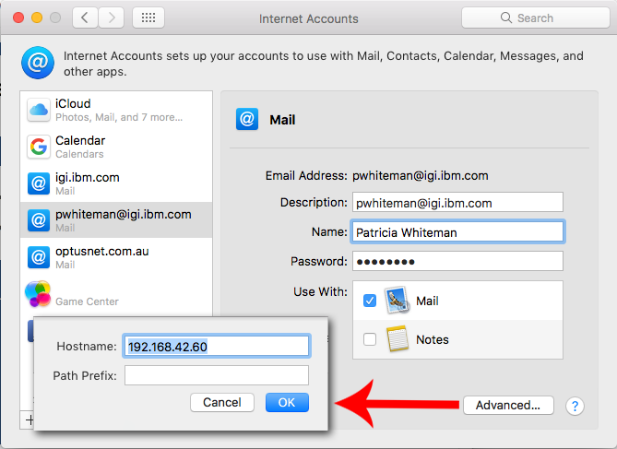

192.168.42.65

## C.2 – Setup Example (Thunderbird on Mac)

Here’s another example (Mozilla account setup)

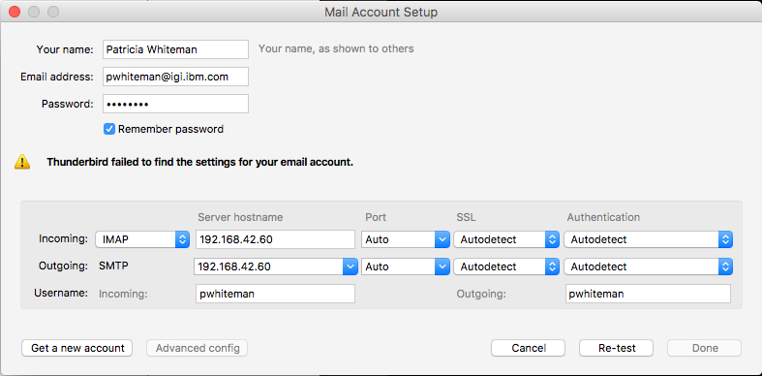

NOTE – the screen shot above shows an old hostname. The current hostname is 192.168.42.65.

SSL is not turned on for the SMTP/IMAP services on the training VM.

## C.3 – Setup Example (Thunderbird on Windows Server)

If you need to setup an email account on the Windows Server VM, use the following steps.

* Open the **Mozilla Thunderbird** application (desktop or task bar)
* Select the “**Display the Thuderbird Menu**” icon (three horizontal bars) in the top right of the Thunderbird application
* Select **Options > Account Settings**
* On the Account Settings dialog, select the **Account Actions** button at the bottom of the settings list
* Select **Add mail account**
* On the Mail Account Setup dialog enter
  + Your name = Patricia Whiteman
  + Emial address = [pwhiteman@igi.ibm.com](mailto:pwhiteman@igi.ibm.com)
  + Password = Passw0rd

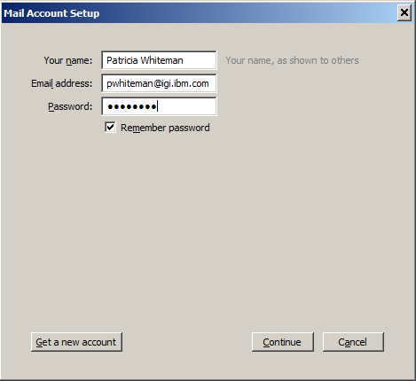

* Click the **Continue** button

Thunderbird will try to resolve and find igi.ibm.com which doesn’t exist.

* Click the **Manual Configuration** button
* Enter 192.168.42.65 into the hostname fields for both IMAP SMTP

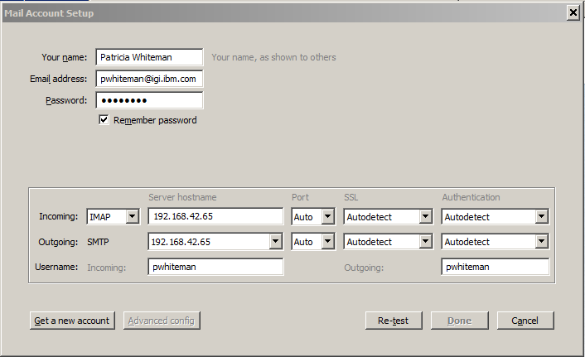

* Click the **Re-test** button

When it completes it will display information about the mail services.

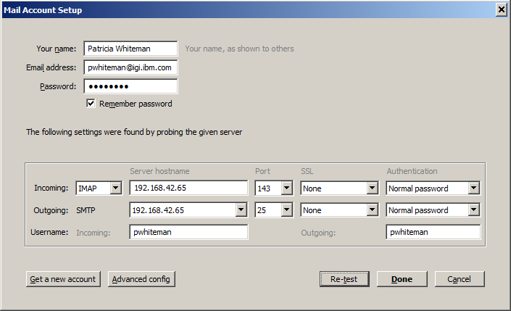

* Click Done to finish
* On the Warning dialog (unencrypted connections), Select the I understand the risks checkbox, and click Done.
* Click Cancel to close the Account Settings dialog
* Select Patricia’s inbox and have a look at the emails retrieved from the server

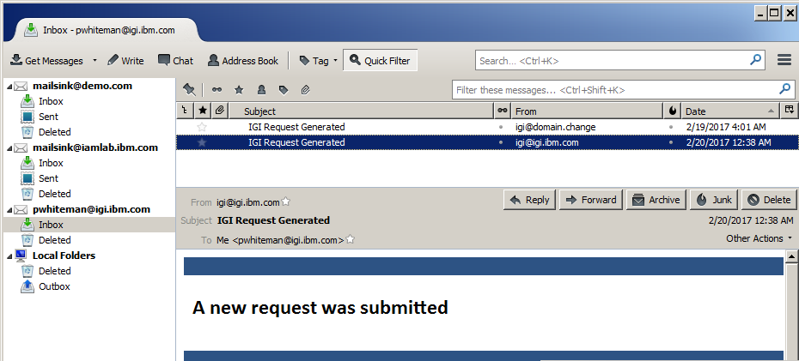

This confirms that Thunderbird is setup to receive emails for Patricia.

## C.4 – Email Client Setup Issues

Every email client seems to have a unique requirement. The following issues have been found:

* Instead of using [pwhiteman@igi.ibm.com](mailto:pwhiteman@igi.ibm.com), you may need to use just pwhiteman
* You may need to setup a hosts entry to point igi.ibm.com to 192.168.42.65

# Appendix D – Environment Utilities

The IGI Data Server VM has been pre-loaded with some shell commands to make working with the image a bit easier. They are a hangover from the older single-VM training environment (based on the DISTRO). You will not need to use any of these utilities in the labs, but the information is left here for reference.

These live under the tools directory (cd ~/tools) for the igi user.

The core commands are:

* **check_igi_status.sh** – Check if IGI and the Broker are running (doesn’t apply to the current training environment)
* **clear_igi_all.sh** – Clear the websphere logs. Needed for applying application server patches
* **restore*.sh and snap*.sh** – Commands to take and restore snapshots (see next section)
* **start_broker.sh** and **start_igi.sh** – Start the Broker or IGI applications (and associated datastores)
* **stop_broker.sh** and **stop_igi.sh** – Stop the Broker or IGI applications (and associated datastores).

There may be some other commands that may have been added to the VM and are not listed above.

## D.1 Database Snapshots

The following information is for those that wish to reuse the training image for demo’s and PoCs. We normally don’t use the DB snapshot mechanism unless there are issues with the VM and we need to restore to a known point.

We use a snapshot mechanism to manage datasets for training and demo’s. This makes sharing and reusing datasets much easier than full VM snapshots.

In the VM, under the tools directory are the following directories;

snapshots

snapshots/demo

snapshots/empty

snapshots/training

Each is used to store different snapshots used in demonstrations, PoCs (empty) and training.

There are commands to take a snapshot for each of the IGI and Broker DBs; **snap_igi_db.sh** and **snap_broker_db.sh**. These commands use database tools to export the schema and data from the relevant database (igiinst for the IGI DB and igildap for the IGI LDAP db) and write the output in a tzg (Tar GZip) format.

Restoring a snapshot involves running the appropriate restore command with the relevant snapshot file; **restore_igi_db.sh** or **restore_broker_db.sh**.

The following shows some of the training snapshots in the VM.

[igi@igi tools]$ ls -l snapshots/training/

total 1895232

-rw-r--r-- 1 igi igi 19844554 Mar 13 21:52 Snapshot_db_BROKER_522v2-00-TrgStart.tgz

-rw-r--r-- 1 igi igi 19999333 Mar 13 21:52 Snapshot_db_BROKER_522v2-01-AfterDataLoad.tgz

-rw-rw-r-- 1 igi igi 20084398 Mar 20 07:38 Snapshot_db_BROKER_522v2-02-AfterMitigation.tgz

-rw-rw-r-- 1 igi igi 375099663 Mar 23 23:56 Snapshot_db_BROKER_522v2-03-AfterRoleMining.tgz

-rw-r--r-- 1 igi igi 374427182 Mar 13 21:57 Snapshot_db_IGI_522v2-00-TrgStart.tgz

-rw-r--r-- 1 igi igi 377169255 Mar 13 21:58 Snapshot_db_IGI_522v2-01-AfterDataLoad.tgz

-rw-rw-r-- 1 igi igi 375090252 Mar 20 07:39 Snapshot_db_IGI_522v2-02-AfterMitigation.tgz

-rw-rw-r-- 1 igi igi 378971105 Mar 23 23:58 Snapshot_db_IGI_522v2-03-AfterRoleMining.tgz

The highlighted snapshots are for the lab start state. They may be used if you need to restore back to the start of the labs.

If restoring both snapshots, you need to restore the broker DB and then the IGI DB snapshots (IGI must be started after Broker).

[igi@igi tools]$ ./restore_broker_db.sh snapshots/training/Snapshot_db_BROKER_522v2-00-TrgStart.tgz

BROKER APPSERV AUTOMATIC STOP

--------------------------

BROKER is running, will be stopped before taking a DB LDAP Snapshot!

BROKER will be restarted as soon as DB LDAP Snapshot is completed.

BROKER: stopping...

######### (100%)

IGI/BROKER IMPDB TOOLS V. 2.0 [DB2]

-----------------------------------

<-> Import Status Configuration:

> IGI/BROKER VERSION : 5.2.2

> Print output messages? YES

<-> Cleaning previous activities

> Delete old restored LDAP DB

> Delete old restored TMP/LDAP_DB

(100%)

<-> Opening IGI/BROKER LDAP Snapshot DB snapshots/training/Snapshot_db_BROKER_522v2-00-TrgStart.tgz

# (100%)

<-> Restoring ibmslapd.conf

(100%)

<-> Restoring IGI/BROKER LDAP DB

SQL2540W Restore is successful, however a warning "2539" was encountered

during Database Restore while processing in No Interrupt mode.

SQL1064N DB2STOP processing was successful.

SQL1063N DB2START processing was successful.

(100%)

IGI/BROKER LDAP Snapshot Restored.

----------------------------------

DB DATA SNAPSHOT snapshots/training/Snapshot_db_BROKER_522v2-00-TrgStart.tgz Restored.

IGI/BROKER APPSERV AUTOMATIC RESTART

------------------------------------

BROKER: restarting...

############################################################# (100%)

If the Broker application had been running then the scripts would have stopped the Broker, restored the snapshot, then restarted the Broker.

The IGI DB restore is similar.

[igi@igi tools]$ ./restore_igi_db.sh snapshots/training/Snapshot_db_IGI_522v2-00-TrgStart.tgz

IGI APPSERV AUTOMATIC STOP

--------------------------

IGI is running, will be stopped before restoring DB Snapshot!

IGI will be restarted as soon as DB Snapshot restore is completed.

IGI: stopping...

### (100%)

IGI IMPDB TOOLS V. 9.0 [DB2]

----------------------------

<-> Import Status Configuration:

> IGI VERSION : 5.2.2

> Print output messages? YES

<-> Cleaning previous activities

> Delete old restored IGI DB

> Delete old restored TMP/IGI_DB

(100%)

<-> Opening IGI Snapshot DB snapshots/training/Snapshot_db_IGI_522v2-00-TrgStart.tgz

## (100%)

<-> Restoring IGI DB

SQL2540W Restore is successful, however a warning "2539" was encountered

during Database Restore while processing in No Interrupt mode.

SQL1064N DB2STOP processing was successful.

SQL1063N DB2START processing was successful.

(100%)

IGI DB Snapshot Restored.

--------------------------

DB DATA SNAPSHOT snapshots/training/Snapshot_db_IGI_522v2-00-TrgStart.tgz Restored.

IGI APPSERV AUTOMATIC RESTART

-----------------------------

IGI: restarting...

################### (100%)

If the IGI application had been running then the scripts would have stopped IGI, restored the snapshot, then restarted IGI.

The data is now ready to be used.

## D.2 Application Server Snapshots

The following information is for those that wish to reuse the training image for demo’s and PoCs. We don’t use this application snapshot mechanism for the training labs, we use the VMWare snapshot mechanism.

As we can save and restore the data, we also have commands to save and restore the application server instances.

It is used to apply patches, where the owner of the VM applies updates and then takes a snapshot which is shared and restored in individual VM environments. It is rarely used.

The commands are;

* **snap_broker_appserver.sh** and **snap_igi_appserver.sh** – to take a copy of an application server, and
* **restore_broker_appserver.sh** and **restore_igi_appserver**.sh – to restore a copy of an application server.

The command structure is the same as for the db commands above; the snap commands don’t have any arguments, the restore commands need the snapshot filename (with path).

## D.3 Use of sudo

You can use sudo to run superuser commands. For example, to shutdown the system you can run:

sudo poweroff

You can even sudo to su to operate as root, but you shouldn’t need to.

The common commands you may want to use:

* **sudo poweroff** – power off the virtual machine
* **sudo reboot** – reboot the virtual machine
* **sudo shutdown now** – shutdown but don’t poweroff the VM

# Appendix E – IGI Data Server VM Components

This appendix lists the operating system and products installed on the IGI Data Server VM.

**Linux System**

|  |  |
| --- | --- |
| **Version** | 2.6.32-642.11.1.el6.x86_64 |
|  | CentOS 6.8 |
| **Hostname** | igi.ibm.com |
| **Root access** | Via sudo only |

**IGI Database**

|  |  |
| --- | --- |
| **Version** | 10.5.0.5 (Fixpack 5) |
| **Install location** | /opt/IBM/db2/V10.5 |
| **Install owner** | bin / bin |

IGI DB Instance:

|  |  |
| --- | --- |
| **Owner** | igiinst |
| **igiinst (IGI DB)** | /home/igiinst/igiinst |
| **Network port** | 50000 |
| **Install owner** | igiinst / db2iadm1 |

IGI LDAP Instance:

|  |  |
| --- | --- |
| **Owner** | igildap |
| **igiinst (IGI DB)** | /home/igildap/igildap |
| **Network port** | None enabled |
| **Install owner** | igiinst / db2iadm1 |

**Broker LDAP**

|  |  |
| --- | --- |
| **Version** | 6.4.0.0 (no fixpacks) |
| **Install location** | /opt/ibm/ldap/V6.4/ |
| **Instance directory** | /home/igildap/idsslapd-igildap/ |
| **LDAP port** | 389 |
| **SSL port** | Not enabled |
| **LDAP log** | /opt/IBM/SDI1/V7.1.1.timsol/logs/ibmdi.log |
| **Install owner** | igildap / idsldap |

**TDI**

|  |  |
| --- | --- |
| **Version** | 7.1.1.5 (FixPack 5, Sept 2015) |
| **Install location** | /opt/IBM/SDI1/V7.1.1 |
| **Solution directory** | /opt/IBM/SD11/V7.1.1/timsol |
| **RMI port** | 1199 (e.g. 172.16.111.142:1199) |
| **RMIDispatcher** | 6.0.34.66 |
| **TDI log** | /opt/IBM/SDI1/V7.1.1.timsol/logs/ibmdi.log |
| **Install owner** | igi / igi |

Additional software on the VM:

* dovecot – IMAP/POP3 server for email clients to connect to. It is listening to port 143 (IMAP) and 110 (POP3).
* postfix – SMTP server for IGI to send emails to. It is listening to port 25 (SMTP).

Whilst the image is built on a standard Linux distribution, a lot of functionality is disabled to reduce space and memory use.

# Appendix F – Special Instructions for SCS-Local

For some live classes we are using a new local server environment (based on ESX and some complex network configuration) to emulate the cloud-based SCS-Portal. For this lab guide we are calling this SCS-Local. This setup uses the same four VMs as listed in the main body of the document and the labs run the same way, but there are some special requirements for accessing the systems.

## F.1 – Connect to the Dedicated IGI Wireless Network

To access the SCS-Local images, you will need to be connected to the dedicated IGI wireless network.

Connect to the network. Wireless newtork is “igi” with a password of “igiwap3lse”

## F.2 – The VMs and Local Access

The same four VMs described in the main document are used; the IGI Virtual Appliance (VA), IGI Data Server, a Windows Server 2008R2 image and a Windows Server 2016 image.

The Windows Server 2008R2 image is considered a “jump box” – it is the machine you will access to run all of the labs. It must be connected to via RDP. Most of the labs will use the Firefox browser to access the IGI UIs. There will be no provisioning to AD on that image.

The Windows Server 2016 image is just an AD system. The current one does not have Terminal Services installed, so you cannot RDP to it. This may be an issue with the Windows AD adapter lab (last part).

The two IGI VMs are used as described in the main document, however the current SCS-Local network configuration does not allow direct access to the terminal sessions. You should not need to access them as the images are up and running. However, if there are steps in the lab that talk about accessing the data server or the VA Command Line Interface (CLI) then you will need to SSH from the Windows Server 2008 machine.

## F.3 – Software to RDP to the Windows Server

You will need to use a Remote Desktop connection (Remote Desktop Services, using RDP), running on your own laptop, to connect to the lab systems. All the lab work will be performed from these systems.

If you are running a Windows laptop the required RDP client software is part of the operating system; you do not need additional software.

If you are running a Mac you will need to install the Windows RDP client, called the "Remote Desktop app for macOS" from the Apple App Store (iTunes: <https://itunes.apple.com/us/app/microsoft-remote-desktop/id1295203466?mt=12>). For more information see: <https://cloudblogs.microsoft.com/enterprisemobility/2017/11/28/new-remote-desktop-app-for-macos-available-in-the-app-store/> ."

## F.4 – Connecting to the Windows Server via RDP on Mac

Once you have an RDP client running you will need to connect to the Windows Server 2008R2 image. The following details are for the Mac RDP client linked-to above.

When configuring the RDP client, you will only need the PC Name (which is that network IP address for the Windows Server 2008R2 image). The common network used by all of the students in the class is 192.168.40.0/24 and each student will have a unique number assigned. The PC Name for each student to get to the Windows Server 2008R2 image is ***192.168.40.<student# + 50>***. For example, if your student number is 01, then the IP you need is 192.168.40.51. If your student number is 20, then your IP you need is 192.168.40.70 (as shown in the following figure).

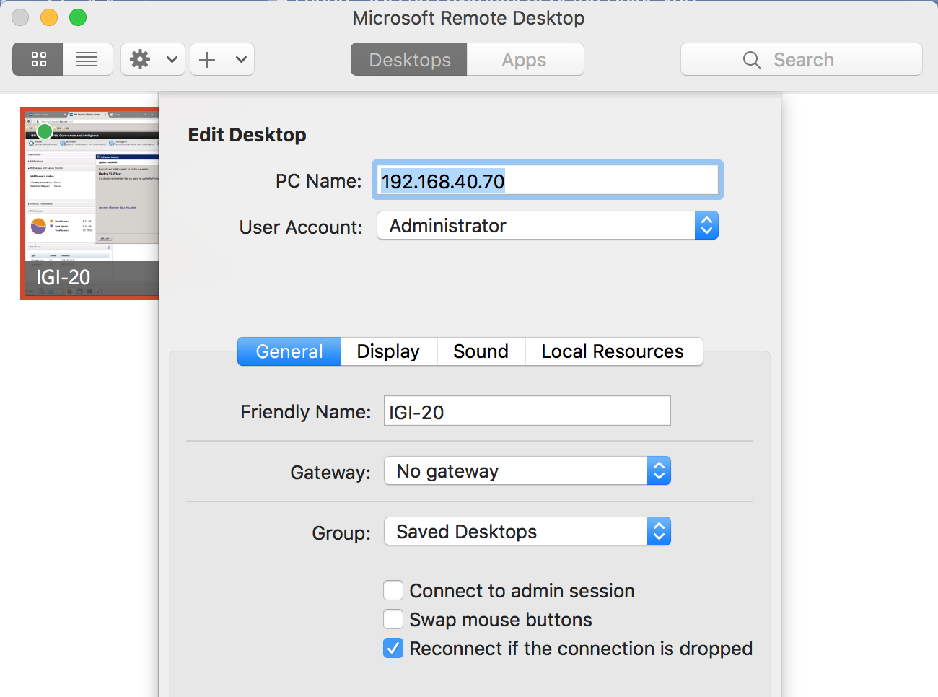

You can select ***Administrator*** as the user to connect to.

You should be able to double-click the desktop to open the RDP session.

## F.5 – Connecting to the Windows Server via RDP on Windows

Using RDP on a Windows laptop will depend on the Windows OS running. For Windows 7 or Windows 10 you can run **Remote Desktop Connections** from the Start menu.

When configuring the RDP client, you will only need the Computer (which is that network IP address for the Windows Server 2008R2 image). The common network used by all of the students in the class is 192.168.40.0/24 and each student will have a unique number assigned. The Computer name for each student to get to the Windows Server 2008R2 image is ***192.168.40.<student# + 50>***. For example, if your student number is 01, then the IP you need is 192.168.40.51. If your student number is 20, then your IP you need is 192.168.40.70 (as shown in the following figure).

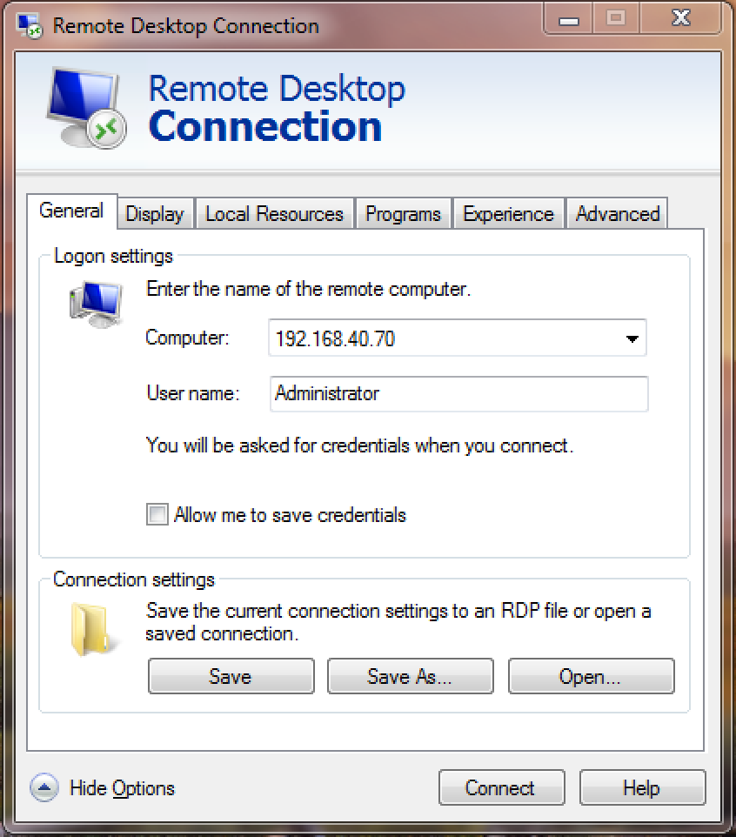

You can select ***Administrator*** as the user to connect to.

## F.6 – Issues Connecting to Windows Server 2016 Image

There have been some issues identified with recent patches to Windows 7/10 and the Windows Server 2016. It may be that 2016 will not trust the RDP’ing PC and block the RDP session.

The instructor may need to lower the security settings on Win 2016.

To do this go to **Server Manager > Local Server**, find the **Remote Desktop** option and click the setting (e.g. “Enabled”). In the **Remote Desktop** section of the **System Properties** dialog, disable the checkbox under the option of “Allow remote connections to this computer” as shown below.

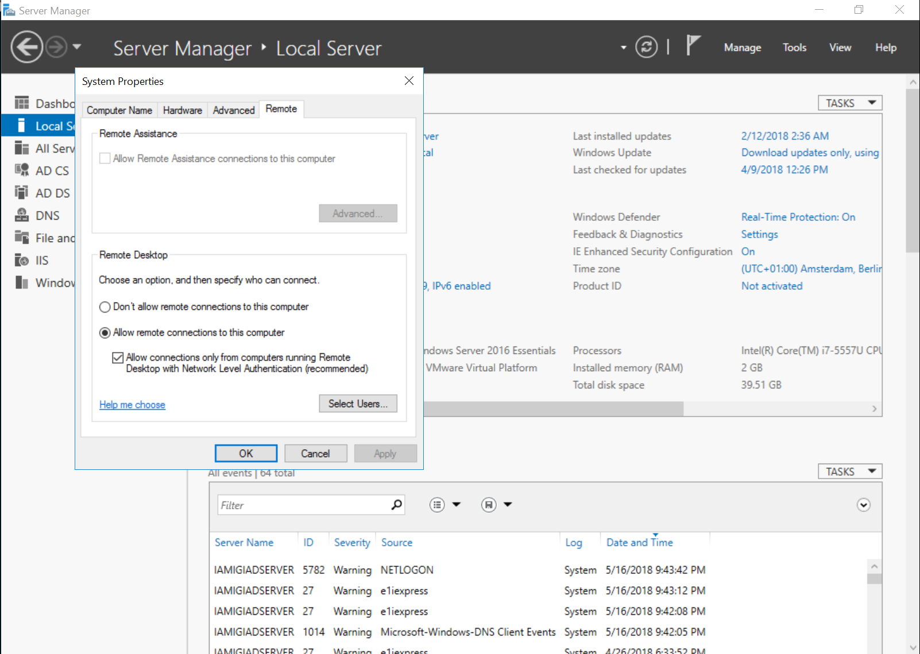

Disable the checkbox and click OK.

# Notices

This information was developed for products and services offered in the U.S.A. IBM may not offer the products, services, or features discussed in this document in other countries. Consult your local IBM representative for information on the products and services currently available in your area. Any reference to an IBM product, program, or service is not intended to state or imply that only that IBM product, program, or service may be used. Any functionally equivalent product, program, or service that does not infringe any IBM intellectual property right may be used instead. However, it is the user's responsibility to evaluate and verify the operation of any non-IBM product, program, or service.

IBM may have patents or pending patent applications covering subject matter described in this document. The furnishing of this document does not give you any license to these patents. You can send license inquiries, in writing, to:

IBM Director of Licensing  
IBM Corporation  
North Castle Drive  
Armonk, NY 10504-1785 U.S.A.

For license inquiries regarding double-byte character set (DBCS) information, contact the IBM Intellectual Property Department in your country or send inquiries, in writing, to:

Intellectual Property Licensing  
Legal and Intellectual Property Law  
IBM Japan, Ltd.  
19-21, Nihonbashi-Hakozakicho, Chuo-ku  
Tokyo 103-8510, Japan

**The following paragraph does not apply to the United Kingdom or any other country where such provisions are inconsistent with local law :**

INTERNATIONAL BUSINESS MACHINES CORPORATION PROVIDES THIS PUBLICATION "AS IS" WITHOUT WARRANTY OF ANY KIND, EITHER EXPRESS OR IMPLIED, INCLUDING, BUT NOT LIMITED TO, THE IMPLIED WARRANTIES OF NON-INFRINGEMENT, MERCHANTABILITY OR FITNESS FOR A PARTICULAR PURPOSE.

Some states do not allow disclaimer of express or implied warranties in certain transactions, therefore, this statement might not apply to you.

This information could include technical inaccuracies or typographical errors. Changes are periodically made to the information herein; these changes will be incorporated in new editions of the publication. IBM may make improvements and/or changes in the product(s) and/or the program(s) described in this publication at any time without notice.

Any references in this information to non-IBM Web sites are provided for convenience only and do not in any manner serve as an endorsement of those Web sites. The materials at those Web sites are not part of the materials for this IBM product and use of those Web sites is at your own risk.

IBM may use or distribute any of the information you supply in any way it believes appropriate without incurring any obligation to you.

Licensees of this program who wish to have information about it for the purpose of enabling: (i) the exchange of information between independently created programs and other programs (including this one) and (ii) the mutual use of the information which has been exchanged, should contact:

IBM Corporation  
2Z4A/101  
11400 Burnet Road  
Austin, TX 78758 U.S.A.

Such information may be available, subject to appropriate terms and conditions, including in some cases payment of a fee.

The licensed program described in this document and all licensed material available for it are provided by IBM under terms of the IBM Customer Agreement, IBM International Program License Agreement or any equivalent agreement between us.

Any performance data contained herein was determined in a controlled environment. Therefore, the results obtained in other operating environments may vary significantly. Some measurements may have been made on development-level systems and there is no guarantee that these measurements will be the same on generally available systems. Furthermore, some measurement may have been estimated through extrapolation. Actual results may vary. Users of this document should verify the applicable data for their specific environment.

Information concerning non-IBM products was obtained from the suppliers of those products, their published announcements or other publicly available sources. IBM has not tested those products and cannot confirm the accuracy of performance, compatibility or any other claims related to non-IBM products. Questions on the capabilities of non-IBM products should be addressed to the suppliers of those products.

All statements regarding IBM's future direction or intent are subject to change or withdrawal without notice, and represent goals and objectives only.

All IBM prices shown are IBM's suggested retail prices, are current and are subject to change without notice. Dealer prices may vary.

This information is for planning purposes only. The information herein is subject to change before the products described become available.

This information contains examples of data and reports used in daily business operations. To illustrate them as completely as possible, the examples include the names of individuals, companies, brands, and products. All of these names are fictitious and any similarity to the names and addresses used by an actual business enterprise is entirely coincidental.

**COPYRIGHT LICENSE:**

This information contains sample application programs in source language, which illustrate programming techniques on various operating platforms. You may copy, modify, and distribute these sample programs in any form without payment to IBM, for the purposes of developing, using, marketing or distributing application programs conforming to the application programming interface for the operating platform for which the sample programs are written. These examples have not been thoroughly tested under all conditions. IBM, therefore, cannot guarantee or imply reliability, serviceability, or function of these programs. You may copy, modify, and distribute these sample programs in any form without payment to IBM for the purposes of developing, using, marketing, or distributing application programs conforming to IBM's application programming interfaces.

Each copy or any portion of these sample programs or any derivative work, must include a copyright notice as follows:

© IBM 2017. Portions of this code are derived from IBM Corp. Sample Programs. © Copyright IBM Corp 2017. All rights reserved.

If you are viewing this information in softcopy form, the photographs and color illustrations might not be displayed.

**Trademarks**

IBM, the IBM logo, and ibm.com are trademarks or registered trademarks of International Business Machines Corp., registered in many jurisdictions worldwide. Other product and service names might be trademarks of IBM or other companies. A current list of IBM trademarks is available on the Web at Copyright and trademark information at ibm.com/legal/copytrade.shtml.

**Statement of Good Security Practices**

IT system security involves protecting systems and information through prevention, detection and response to improper access from within and outside your enterprise. Improper access can result in information being altered, destroyed, misappropriated or misused or can result in damage to or misuse of your systems, including for use in attacks on others. No IT system or product should be considered completely secure and no single product, service or security measure can be completely effective in preventing improper use or access. IBM systems, products and services are designed to be part of a comprehensive security approach, which will necessarily involve additional operational procedures, and may require other systems, products or services to be most effective. IBM DOES NOT WARRANT THAT ANY SYSTEMS, PRODUCTS OR SERVICES ARE IMMUNE FROM, OR WILL MAKE YOUR ENTERPRISE IMMUNE FROM, THE MALICIOUS OR ILLEGAL CONDUCT OF ANY PARTY.

© International Business Machines Corporation 2017

International Business Machines Corporation  
New Orchard Road Armonk, NY 10504

Produced in the United States of America 01-2016

All Rights Reserved

References in this publication to IBM products and services do not imply that IBM intends to make them available in all countries in which IBM operates.